




Confidential REPORT

Prepared for:
Carbon Connections
Ashton Hayes Parish Council



A Community Microgrid for Ashton Hayes

Authors: Mary Gillie, Jen Carter, Roy Alexander

Report No:6456

Project No: 73430

April 2009

Project No: 73430
A Community Microgrid For Ashton Hayes

Client(s)

Carbon Connections

Ashton Hayes Parish Council

CONFIDENTIAL - This document may not be disclosed to any person other than the addressee or any duly authorised person within the addressee's company or organisation and may only be disclosed so far as is strictly necessary for the proper purposes of the addressee which may be limited by contract. Any person to whom the document or any part of it is disclosed must comply with this notice. A failure to comply with it may result in loss or damage to EATL or to others with whom it may have contracted and the addressee will be held fully liable therefor.

Care has been taken in the preparation of this Report, but all advice, analysis, calculations, information, forecasts and recommendations are supplied for the assistance of the relevant client and are not to be relied on as authoritative or as in substitution for the exercise of judgement by that client or any other reader. EA Technology Ltd. nor any of its personnel engaged in the preparation of this Report shall have any liability whatsoever for any direct or consequential loss arising from use of this Report or its contents and give no warranty or representation (express or implied) as to the quality or fitness for the purpose of any process, material, product or system referred to in the report.

All rights reserved. No part of this publication may be reproduced or transmitted in any form or by any means electronic, mechanical, photocopied, recorded or otherwise, or stored in any retrieval system of any nature without the written permission of the copyright holder.

© EA Technology Ltd April 2009

EA Technology Limited, Capenhurst Technology Park, Capenhurst, Chester, CH1 6ES; Tel: 0151 339 4181 Fax: 0151 347 2404
http://www.eatechnology.com
Registered in England number 2566313

A Community Microgrid

by

Mary Gillie, Jen Carter, Roy Alexander

Summary

At a time of serious concern over climate change and volatile energy prices, communities are increasingly concerned about where their energy comes from and the resulting carbon emissions. There is a renewed interest in small-scale renewable generation at a community scale. Ashton Hayes, a village just outside Chester is a good example of how these concerns can be translated into action. The village is trying to become carbon neutral and as a result it is interested in generating its power from renewable sources locally.

This project used Ashton Hayes as a case study to develop an economic and technical model for communities to
- install renewable generation,
- match their load to the locally generated power with automatic demand side management,
- develop a local energy economy.

The project monitored local power use, the available renewable energy resources and developed an economic model. Throughout the community participated and were consulted. For the model to achieve maximum benefit, smart meters recording power use on a half-hourly basis and automatic demand side management are required. The project investigated, different types of small scale renewable energy, the best methods to connect renewable generation and legal structures for community management of the generation. It aimed to provide a generic model that can be used in many communities.

However, the energy markets and the electricity distribution system in the UK is not currently designed to incorporate small scale renewable generation. Until the market is changed to include half-hourly metering at the domestic level, the model cannot be fully implemented.

This report provides recommendations tailored to Ashton Hayes. In Ashton Hayes, it recommends installing wind turbines, photovoltaics and CHP with a seasonal heat store. It recommends that this should be owned by a community organisation.

Contents

Page
1 Introduction 1
2 Overall Concept and Philosophy 1
3 Ashton Hayes 2
4 Approach to the Project 5
5 Community Consulation 5
6 Distributed Energy 6
6.1 Who’s who in the Electricity industry? 7
6.2 Licensed & Unlicensed Parties – the distinctions 9
7 Renewable Technologies 9
7.1 Wind 10
7.1.1 Noise 10
7.1.2 Interference with telecommunications 11
7.1.3 Impact on Birds and Bats 11
7.2 Solar 11
7.3 Biomass and Biodiesel 12
7.4 Planning 13
7.5 Generation models 13
7.6 Advantages and Disadvantages of Larger or Smaller Generation 18
7.7 Monitoring renewable resources at Ashton Hayes 18
8 Assessing a Community’s Demand Profile 20
8.1 Profiles in Ashton Hayes 21
8.2 Matching Generation to Demand 21
8.3 Determining heat load 22
8.3.1 Ashton Hayes School 23
8.3.2 Storing heat 24
9 Connection to the Public Network 24
9.1 A Focus for the Microgrid in Ashton Hayes 28
10 Metering 28
11 Demand Side Management Technologies 30
12 Energy Storage – Electrical and Thermal options 31
12.1 Benefits of Energy Storage 31
12.2 Heat Storage 32
12.3 Electrical Storage 32
13 Size and Extension to a Microgrid 33
14 Commercial Model for the Generation 33
14.1 Background to the Model 34
14.1.1 Relationship between the CORE and a Generator Host 34
15 The Community ESCO model (CORE) 35
16 Establishing a CORE 37
16.1 Types of Organisation 38
16.1.1 Limited Company 38
16.1.2 Social Enterprise 38
16.1.3 Community Interest Company 38
16.1.4 Co-operative 39
16.1.5 Development Trust 39
16.2 Charitable Status 39
16.3 Rules for the CORE 40
16.4 Accountability 40
16.5 Interacting with other Groups/Organisations 40
16.6 Establishing a Support Network 40
17 The Economics of a CORE 41
17.1 Income streams 41
17.1.1 Selling power 41
17.1.2 Renewable energy subsidies 42
17.2 Ongoing Expenditure 43
17.3 Ashton Hayes 43
17.3.1 Best Case 44
17.3.2 Worst case 45
17.4 Pricing arrangements 46
17.4.1 EXAMPLE of Pricing and DSM 46
18 Challenges to the Model 49
19 Recommendations For Ashton Hayes 50

Introduction
At a time of serious concern over climate change and volatile energy prices, communities are increasingly concerned about where their energy comes from and the resulting carbon emissions. There is a renewed interest in small-scale renewable generation at a community scale. Ashton Hayes, a village just outside Chester is a good example of how these concerns can be translated into action. The village is trying to become carbon neutral and as a result it is interested in generating its power from renewable sources locally.

However, the energy markets and the electricity distribution system in the UK are not currently designed to incorporate small scale renewable generation. In addition, in the past, domestic customers have been viewed as passive consumers of power. There is therefore little understanding of how they may react to measures to allow them to take a more active role in managing their energy consumption.

Ashton Hayes offered an excellent opportunity for local company EA Technology and the University of Chester to work with an engaged community to investigate solutions to the issues outlined above. Carbon Connections (a knowledge transfer fund run by the Univeristy of East Anglia) provided the funding for a feasibility study.

Overall Concept and Philosophy
There have been a number of community energy projects in the UK that have installed renewable energy owned, and in certain cases operated, by the community. However these projects have sold all the electrical power generated to a licensed supplier and consumers have then bought power back from a licensed supplier (i.e. a company that sells power to domestic customers, see section 6.1). Profits have been shared amongst shareholders, used for energy efficiency measures for members or to benefit the community as a whole. There are a range of variations on this model. Whilst communities have gained economically from such projects and reduced carbon emissions, there is no link made between the use of power and its generation. Furthermore, the price that a community sells power to a supplier will always be less than the price the supplier sells power to domestic customers.

If a community could use the power generated by community owned generation directly without selling it to a licensed supplier, the economic benefit to the community would be much greater.

Example
Without generation a community buys 5000kWh power at 10p/kWh. This costs £500. If 2000kWh are generated and sold at 5p/kWh to a licensed supplier, the cost of power for the community overall is £500-£100=£400. If the power is used directly, the amount of power that must be bought by the community is 5000-2000=3000kWh. At 10p/kWh, this costs the community £300. Thus, the economic benefit is greater.

For the community to use power directly it must,
- Be consuming power at the same time as it is being generated by the community owned generation.
- Be able to demonstrate that it used power at the same time as it was generated by the community owned generation.
- Have an economic framework to charge the community for locally generated power and buy or sell any surplus or deficit with a supplier.

Therefore this project aims to develop a model that:
- Finds a mix of generation that is likely to be generating at the same time as power is consumed.
- Provides an economic model for metering, billing and buying and selling any deficit or surplus in locally generated power with a licensed supplier.

There are further advantages to the proposed model as it encourages the community to match their load to generation as far as possible. Known as demand side management (DSM), this reduces network losses transporting electricity (as electricity is used locally) and carbon emissions. It also raises awareness of the generation of power and helps communites take control of their energy use.

Ashton Hayes
This section gives a description of Ashton Hayes and the area of focus for a Microgrid.

The village has around a 1000 inhabitants and is situated about 6 miles from Chester. Housing is a mix of era from the 1600s to present day, with the majority constructed within the last 50 years. The Going Carbon Neutral Project was set up three years ago to try to reduce the village’s carbon emissions to zero.

The feeder supplying power to part of Church Road and Church Court was identified as a suitable focus point to carry out a feasibility study for a microgrid in Ashton Hayes (Error: Reference source not found and Figure 2). The area is suitable as it:
- Has a mix of buildings with different load profiles.
- Is a distinct geographic area.
- Contains community buildings; the school, church, village hall and WI Hall are connected to the feeder so that other villagers have an interest in the area.
- Contains a manageable number of buildings for an initial demonstration project.
If successful, it is envisaged that the microgrid could be extended to the rest of the village.

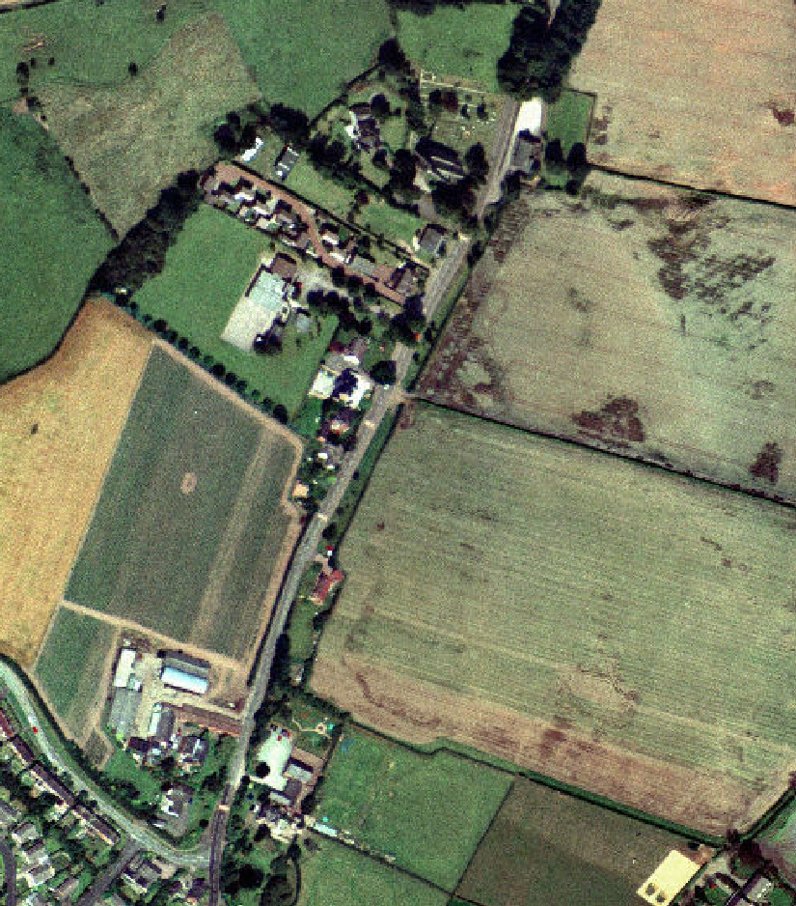
Church Rd
School
Church Ct
Church
Village Hall
WI Hall

Figure 1 Aerial photograph of the area considered in Ashton Hayes

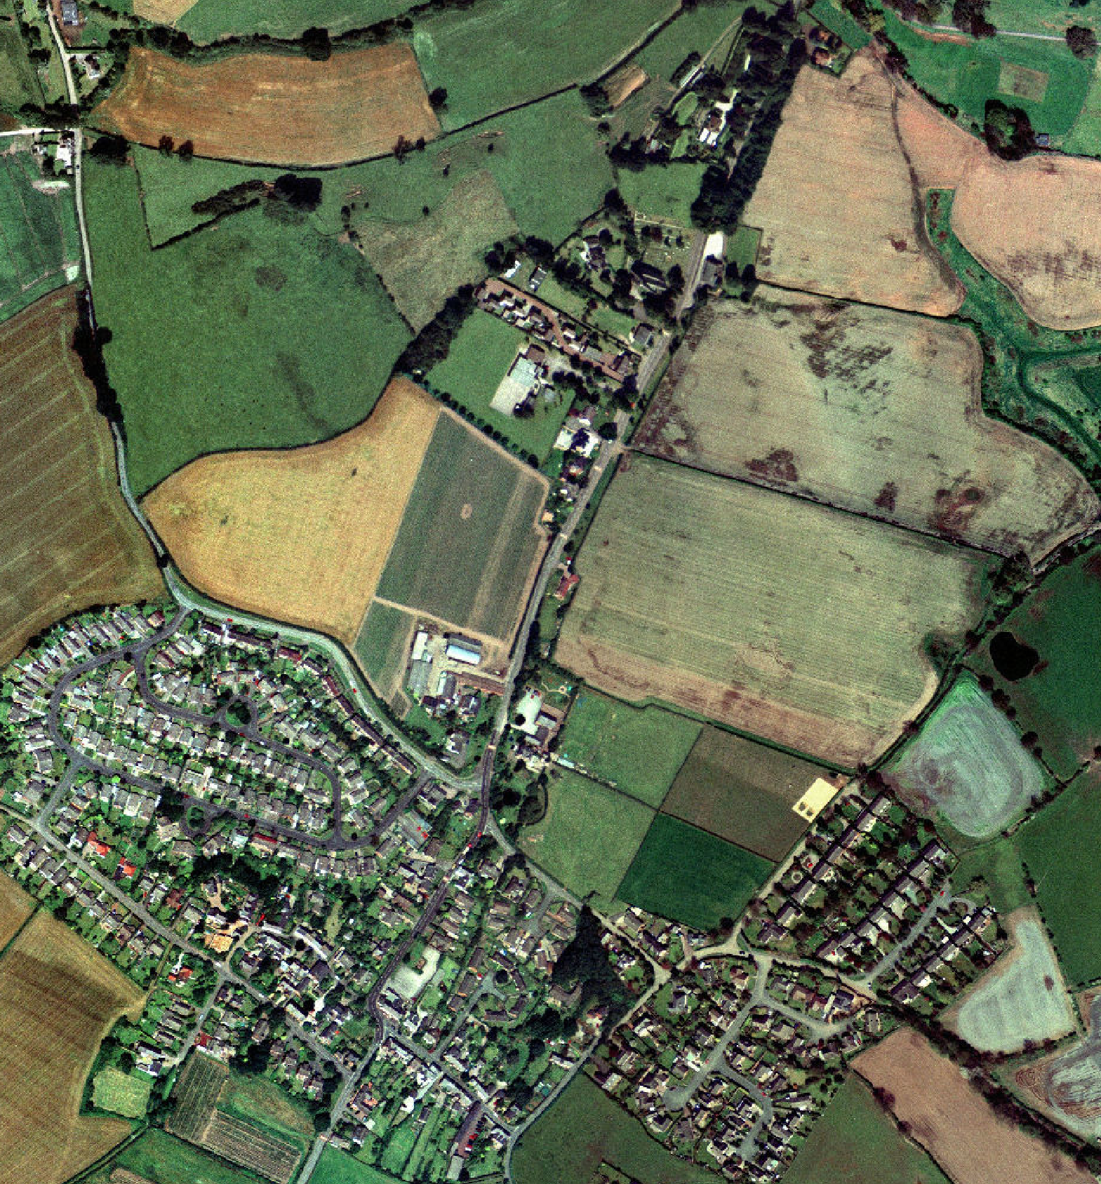
LV line
LV cable

Switch
11kV overhead line

11kV cable
Pole transformer

Figure 2 Aerial photograph of Aston Hayes village with the distribution network marked on.

The field behind the school and Church Court (Figure 1 and Figure 3) was identified as a suitable site for small-scale wind. The owner was willing to consider an installation. An anemometer was erected on a 10m mast to determine the average wind speed. A pyranometer was also installed to record solar energy.

The local distribution network operator recorded the power flow into the feeder and individual householders recorded their usage on a 5 minute basis.

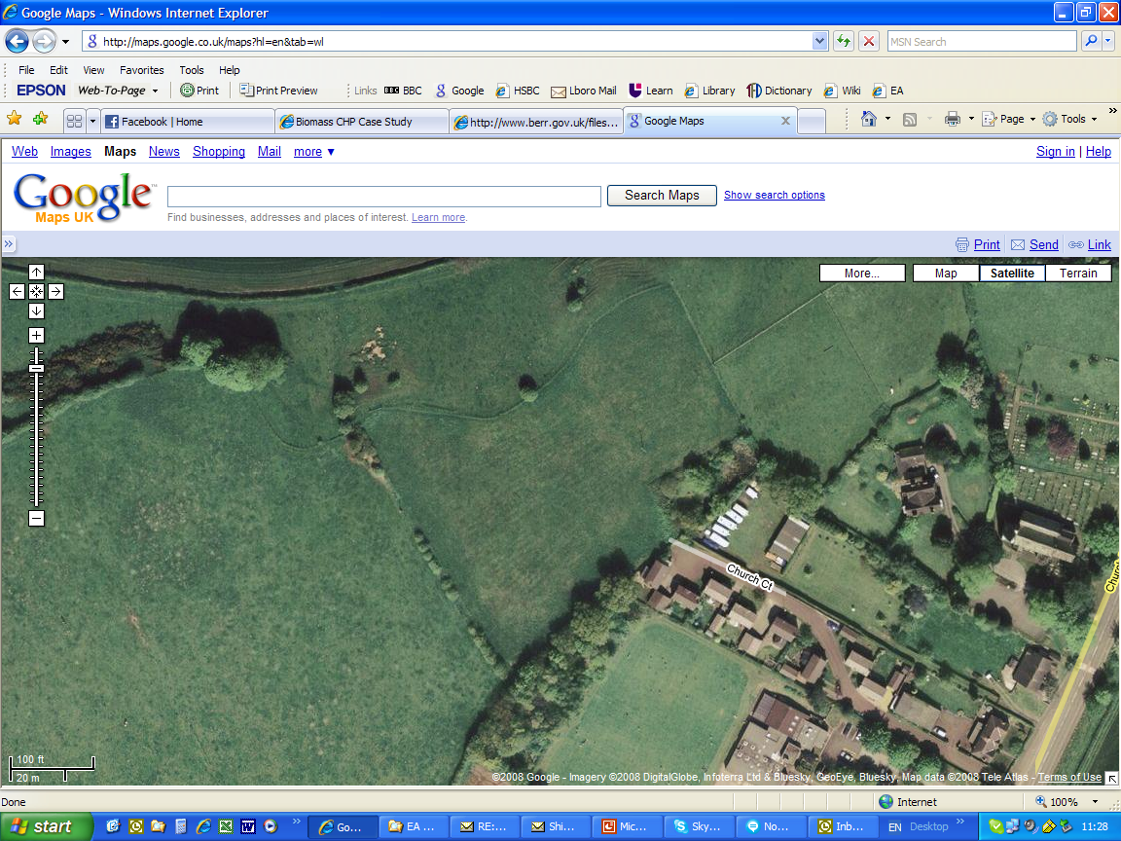
Figure 3 Aerial view of the field where the wind turbines are proposed and the wind was monitored.

Approach to the Project
In order to fulfill the aims of the project, theoretical work was carried out alongside practical work. The practical side of the project took place in the village of Ashton Hayes that was used as a case study.

Appropriate energy monitors were selected to monitor the load profile of volunteer households within Ashton Hayes and ScottishPower agreed to monitor the load profile on two feeders in Ashton Hayes and of the school. The village erected two anemometers to monitor the wind and a pyranometer to measure the solar resources. A number of village meetings were held to get feedback as well as meeting with two volunteer focus groups on a more regular basis. The focus groups studied technical and economic issues. Example notes from these meetings are in Appendix III.

At the same time suitable technologies for generation and connection to the network were identified. Discussions with OFGEM, suppliers and other members of the industry aimed to get the views of the different industry stakeholders. The organisation Leapfrog provided invaluable legal advice. This information was used to develop a generic business model and general technical recommendations.

Community Consulation
Consulating with the residents of Ashton Hayes has been crucial throughout the project to get their views and feedback. This has been used to tailor the proposed models to their needs.

Contact was made with Ashton Hayes Parish Council at an early stage and public speaking time at a parish council meeting was used to announce the project. There was a joint Memorandum of Understanding (see Appendix III). As the project proceded occasional reports were made to parish council meetings and council members were invited to a final public meeting at which project outcomes and proposals for the implementation of a microgrid in Ashton Hayes were presented.

Meeting were held with key stakeholders including the headmaster and governors of the village school, the Parochial Church Council and members of the Village Hall and WI committees.

Priority was given to keeping the village community informed of progress throughout the duration of the project. The first step was to circulate an information sheet (see Appendix III) explaining the background to the project, describing what it would involve and raising and answering some key questions. Shortly after its distribution a public meeting was held in the village school to provide more information about the project, to answer questions and to recruit residents to form two focus groups to maintain an active involvement in the development of the work.

Key steps at the outset of the work were to recruit households within the study area to host Wattson energy meters and to seek permission from landowners for the installation of temporary weather stations at suitable sites. Eight houses, representing the range of building types and occupant demographics present in the area, were selected to host the meters. A ninth meter was installed in the WI Hall and a tenth at the primary school to enable the pupils to become familiar with its operation and significance.

Two residents were keen to have weather stations installed on their land; one on land immediately behind the village school and the other on higher ground just beyond the village boundary in the neighbouring parish of Kelsall. Teams of village residents were recruited to help with the installation of the weather stations, turning these occasions into community events.

Two focus groups were established following the initial public meeting and the distribution of a further circular. One concentrated on technical options for generation and metering whilst the other considered ESCo (Energy Services Company) ownership and management. Each group met on three occasions within the village with meetings taking the form of an initial presentation by the project team followed by discussion of the issues raised. Information about the major items to be covered was circulated prior to each meeting with a request that group members discuss the issues with friends and neighbours and represent those views at the meetings. In this way a broad level of consultation was carried out at each stage of the work. Following each meeting, copies of presentations and notes of the ensuing discussions (see Appendix III) were published on the Going Carbon Neutral project website inviting comment from other community members. Focus group members were invited to the public meeting held at the end of the project to thank them for their contribution and to inform them of the outcomes of the project and proposals for its continuation.

Distributed Energy
Conventionally our electricity has been supplied by large power stations. This power is transported across the country on what is called the transmission system. This is characterised by large overhead lines and pylons carrying power at high voltages (275kV or 400kV). It is analogous to the motorway system for the electricity system. This system is connected to the electricity distribution system that supplies electricity to factories, shops and homes at decreasing voltages (the lowest being 230V for domestic use). The electricity distribution system was designed just to deliver power to users but increasingly, electricity generators are connecting to it; this is known as distributed energy.
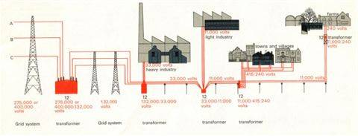
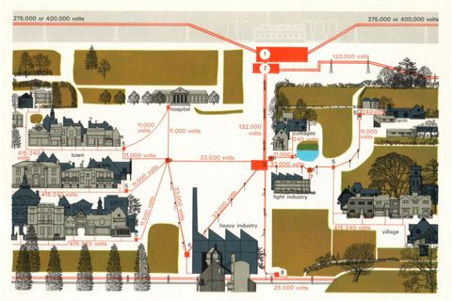
Figure 4 Diagrams of the Transmission Grid and Distribution Systems

Distributed generators are smaller than those connected to the transmission system. The smallest are 1 or 2 kilowatts and the largest a few 10s of megawatts. They often but not exclusively, use renewable energy resources. Distributed generators have the advantage of being closer to where the energy is used and therefore do not use lose as much power in transport. Distributing power across the country also makes the power supply less vulnerable to severe weather conditions or terrorist attack as it is unlikely that a significant proportion of generators will be out of service at any one time.

Who’s who in the Electricity industry?
Whilst there are many players in the UK electricity industry, they tend to divide into a few main groups, responsible for specific aspects of the industry. Figure 5 shows these groups and where they tend to be in the flow of electricity from point of generation to its final consumption. The groups in green are subject to full competition, where anyone can participate if they demonstrate that they comply with the relevant Industry codes.

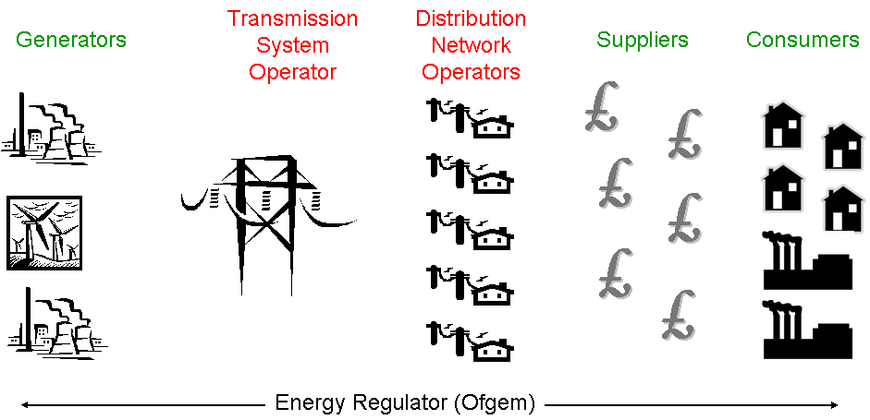
Figure 5 Parties in the UK Electricity Industry

The two groups in red are the roles that are ‘regulated monopolies’. Competition in these areas is problematic to implement as it would potentially result in the development of multiple networks which is not usually cost effective. There is only one Transmission System Operator, National Grid, which is responsible for the transmission systems (as described in section 6). The Distribution Network Operators (DNOs) are responsible for regional networks that connect the high voltage transmission system to different types of consumers at decreasing voltage levels (as described in section 6). As highlighted in section 6), there are increasing numbers of generators connecting to the distribution network which is resulting in the role of the DNO changing from its traditional responsibility of just distributing power to loads.

Generators produce electricity using a number of different fuels and technologies. It is a fully competitive market and there is no obligation on a Generator to run a power station if the prices available in the market would be insufficient to cover the costs incurred in producing the electricity. They tend to divide into two groups: the large generator companies who own and operate power stations and tend to connect to the transmission system; and smaller generators which tend to connect to the distribution system. The majority of renewable generators will fall into this latter group as their output is significantly smaller than that of a large power station. The larger generators are required to notify National Grid of their intended output.

Suppliers buy the electricity from the generators and then sell it to the end consumer. They tend to divide into two main groups, depending on whether or not they supply domestic consumers, but all operate in a similar way. They have to forecast the amount of electricity their customers will use as all trading of electricity takes place before it is used. They are also required to submit a forecast to National Grid of how much electricity they anticipate their customers will require in advance so National Grid can plan how this consumption will match or ‘balance’ the large generators’ forecast output.

After trading has finshed, National Grid is also responsible for ensuring that the electricity system is balanced on a minute-by-minute basis. To do this it will ask large generators to increase or reduce their output to counter any changes. This could be due, for example, to a problem with another power station or a surge in demand for electricity Generators are usually reimbursed for providing any additional output. The costs are then passed to any Generators that do not produce as much electricity as they have forecast or Suppliers whose customers use more electricity than the Supplier has allowed for.

The party responsible for calculating who is responsible for any imbalance in the system (i.e. mismatch in demand and generation) is the Balancing and Settlement Code Company, Elexon. Elexon is responsible for administering the payments between many of the various parties in the supply chain, including redistributing the costs incurred by National Grid in balancing the system, to the generators and suppliers.

OFGEM is responsible for regulating the electricity industry and will grant licenses to the parties described above. Its priority is to protect the interests of the customer and promote competition and it regulates the transmission and distribution operators appropriately to achieve this aim.

Licensed & Unlicensed Parties – the distinctions
The majority of the parties discussed above will be licensed by OFGEM, in accordance with the Electricity Act 1989. There are some exemptions from the requirements to be licensed, as laid down in The Electricity (Class Exemptions from the Requirement for a Licence) Order 2001. For very small suppliers and generators unlicensed supply reduces the regulatory burden and costs that come with being a licensed party. The majority of community energy schemes are likely to fall within these exemptions but it is a complex document and it is important that any community considering this approach seeks professional legal advice.

These exemptions are limited to certain circumstances and discussions with OFGEM suggest a reluctance to increase these circumstances as there tends to be reduced levels of consumer protection associated with unlicensed schemes. As an alternative, OFGEM has proposed developing a second-tier of licensed supplier (where there is the most interest from potential new-entrants such as community energy schemes). OFGEM’s proposal would allow these smaller ‘second-tier’ suppliers to be licensed but to be able to contract some of their license obligations to one of the larger licensed suppliers. The statutory consultation on these proposals closed at the beginning of March 2009 and OFGEM anticiapte developing a working group on the arrangements for the provision of such services over the next few months.

Renewable Technologies
Renewable sources of energy are those that are non-exhaustable (e.g. wind) or replenishable (e.g. wood). Humans have been using renewable sources of energy for millennia and some of the first electric generators were powered from renewable sources. Those sources potentially suitable for Ashton Hayes are described below

Wind
Wind has driven ships and mills for centuries. The first wind turbines were developed in the 1890s but there was no serious industry until the 1970s. The world’s total capacity is now approaching 100GWe.

Wind turbines start to generate electricity from wind speeds of 3-5m/s (the cut-in wind speed) to 25m/s (the cut-out wind speed), however some small turbines have a cut-in wind speeds of 2-3m/s. The amount of energy generated depends on the cube of the wind speed and the area drawn out by the blades. Capacity factor is a measure of the energy generated divided by the energy generated if the turbine operated at full capacity for the whole year. At sites with a good wind resource, typically turbines have a capacity factor of around 30%.

As a rule of thumb the cost of the turbine is around £1000/kW. Small turbines are most expensive and large MW turbines are cheaper per kilowatt.

For small-scale wind where the wind resources are not optimum, the rated wind speed (the speed that produces the rated power output) as well as the cut-in wind speed for different technologies should be considered. As the wind speed may often be low, a low cut-in wind speed is important. If the rated wind speed is relatively high (for example, 14 m/s or above) however, the wind may rarely be that strong. To make the most of resources, tall towers of 20 metres or above should be used.

There are many issues that tend to be raised concerning wind turbines. Below is some basic information on the most common concerns. Links to further sources of information can be found in Appendix II. Manufacturers should be able to provide the results of independent tests of the performance of their turbines.

Noise
Noise is a concern often raised in relation to wind turbines, although it has frequently been exaggerated. Small turbines designed for communities and industry do not tend to have a gear box, which reduces the noise compared to larger turbines. These types of turbines are specifically designed to emit little noise as they are more likely to be closer to homes than large scale turbines. Any foliage or buildings or even rough ground will further dampen any noise. The noise from most well designed small turbines will be between 30-65dB(A) at the base of the tower, depending on the wind speed. Using accepted standards for noise this would result in the noise being at an acceptable level for a house 50 metres from the turbine with no foliage in between.

The decibel scale is logarithmic, not linear. Examples of the loudness of different noises in decibels are as follows:
- office background noise is about 50 dB(A);
- human speech at 3m is about 60dB(A) to 70dB(A);
- cars driving by at 15m is 65-70 dB(A); lorries at 15m is 75-80 dB(A);
- and aircraft overflights directly overhead a mile from the runway is about 95 to 100 dB(A).

The following example quotes are from Proven (a small wind turbine manufacturer) customers and may help to allay any fears about noise.
“The Proven doesn’t roar away but swishes gently. Most of the time it is inaudible because of noises generated by the wind blowing.” Tim Cotter - Energy Advisory Officer Falkland Islands Development Corporation.

“The amazing thing was that the wind blowing past the buildings made more noise than the turbine.... a mere 100 feet away.” Rick Solinsky, Proven Energy Customer, USA.

Any turbine should be independently tested for noise using standard methodologies. These reports can be used in support of planning applications.

Interference with telecommunications
There is no substantiated evidence of small wind turbines interfering with telecommunications or TV signals. There are numerous turbines installed very close to TV and telecommunication sites and, in some areas, wind turbines are used to provide the power for off-grid telecommunication sites.

Impact on Birds and Bats
Studies in the UK have shown that the number of birds colliding with turbines is less than one bird per turbine a year (much less than the number killed by cats, cars or power lines). To put this in context, according to the Scottish Road Safety Campaign in 2004 around 10 million birds were killed by cars in the UK. The RSPB is broadly in support of sensitive development of wind turbines as climate change is a much greater threat to birds. Indeed, it is considering installing wind turbines on some of its reserves.

A study published in the Journal of Applied Ecology showed that birds are not deterred from using land surrounding a wind turbine. In a press report Mark Whittingham, whose team from Newcastle University carried out the research commented
"This is the first evidence suggesting that the present and future location of large numbers of wind turbines on European farmland is unlikely to have detrimental effects on farmland birds".

There is some evidence that wind turbines may pose a threat to migrating bats but this is only a risk if there is a large population of bats near the turbine site. Work on whether a radar signal may deter bats from coming to close to turbines is ongoing.

Solar
Most solar electricity is generated via semiconductors in photovoltaic (PV) arrays. The photovoltaic effect was discovered by Henri Becquerel in 1839. Electrons absorb sunlight and travel from the positive side of a semiconductor cell to the negative side and generate an electrical current to power a load.

The quality of PV cells varies, the best are mono-crystalline that have a conversion efficiency of around 15%, whereas multi-crystalline cells have efficiencies of around 12%. Thin film designs have efficiencies of between 6-12%. New technologies using different structures of semiconductor and different compounds could drastically increase the efficiency of PV systems in the future but are not yet available. For a domestic installation, the costs are around £4000-9000/kWp. Cost savings can be made by connecting a number of arrays using a single invertor. In a community setting, it can therefore be beneficial to combine cells across a number of localised properties and then connect to the public electricity network.

PV cells have the advantage that they are easily incorporated onto existing buildings and have almost no maintenance costs. The output from PV cells depends on:
- The solar irradiance (the amount of solar energy incident on a surface per unit time, per unit area).
- The direction the installation faces. In the northern hemisphere, due south would be the ideal. There are now installations that can track the sun from east to west, maximising the power that can be generated.
- Hours of sunlight.
- The angle of orientation. This is measured from horizontal and the best angle for installations in the UK is between 35 and 45 degrees.
- Size and type of panel.

Solar panels on domestic sites are normally a ‘permitted development’ and therefore do not need planning permission. There are some exceptions, such as on listed buildings and in heritage areas. More information is available at http://www.planningportal.gov.uk/england/genpub/en/1115315772537.html

Biomass and Biodiesel
Organic material can be used to extract energy. If the biomass is replaceable, e.g. wood, energy grasses or the by-products of agriculture or food, then the energy produced can be considered to be renewable. Many technologies are pre-process to increase the energy density of the fuel and the efficiency.

There are three basic technologies that use solid biomass as a primary fuel to produce electricity; direct combustion, gasification and pyrolysis. Direct combustion can produce steam to drive a turbine. Gasification involves the combustion of biomass with a restricted air supply; this partial oxidation at elevated temperatures converts the solid biomass into a gas to drive an engine or a turbine. Pyrolysis involves the thermal degradation of biomass in the complete or nearly complete absence of air, to give a gas, an oil and charcoal. All three products can power engines and turbines.

Other techniques used for processing biomass include; anaerobic digestion where biomass with a high moisture content is broken down by anaerobic microbes to give methane which can be used to power a generator. Examples of raw fuel sources are farm slurries or food waste.

Biomass is generally suited for small power plants, although in many circumstances it may be better to use the biomass to provide heat rather than electricity as this is often a more efficient use of the resource. If there is a heat demand of around 100kW or more, a combined heat and power (CHP) generator can be used. CHP increases the efficient usage of the fuel by making use of the heat that is produced when electricity is generated. There are also some generators that can be fitted with heat recovery systems on their radiators rather than using a purpose made CHP unit. This is less efficient than CHP but may be a cheaper option, depending on the size of unit required.

Biodiesel, sourced from reprocessed food and agricultural waste, can also be used to produce electricity. It is important to establish that the source of the biodiesel is sustainable.

There are some smaller CHP units (in the range of a few 10s of kW of electricity) that can run off biodiesel, rather than biomass, as it is a more conventional fuel. If considering the use of biodiesel as part of a renewable energy scheme, it is important to consider how the biodiesel is produced. OFGEM has recently published a decision on the treatment of biodiesel in relation to the issue of Renewable Obligation Certificates (ROCs) – see section 17.1. The treatment of power produced from biodiesel will depend on whether or not the methane used in its production is produced from fossil fuels or renewable sources. Where the methane is from renewable resources, then the electricity produced should be eligible for ROCs. Where it is from fossil fuels (such as natural gas), the Generator will need to apply to OFGEM who will calculate the proportion of electricity produced that is eligible for ROCs. Most biodiesel manufacturers should be able to advise on how their product sits within this decision.

It is important to note that a normal synchronous generator or internal combustion engine will generate noise. This can be reduced by installing sound proofing in the room where it is installed or if possible separating it from other buildings. It may be replacing a boiler that will also generate some noise.

Costs of biomass generators and CHP units vary considerably depending on the fuel, technology and size.

Planning
If Ashton Hayes designed to develop a renewable energy scheme it will need to consider the requirements of planning law as part of the process. The village should make contact with the local planning department as early as possible as they will be able to provide help and advice. Ashton Hayes and adjacent parish councils are automatically notified but it will be helpful if Ashton Hayes involves them and briefs them on the project plan at any early stage.

Planning Policy Statement 22 on Renewable Energy must be taken into account by local authorities when making decisions on renewable energy projects. Part of one of its key principles requires that “Regional spatial strategies and local development documents should contain policies designed to promote and encourage, rather than restrict, the development of renewable energy resources.”

Many manufacturers and installers provide help and guidance with the planning process as well as information relating to noise, environmental impact and any other issues.

Generation models
The software RetScreen was used to assess the potential locations and outputs from generation at different sites in Ashton Hayes. Examples from Ashton Hayes are given in Table 1 and Table 2. These models could be refined further by using more data from on-site measurements at Ashton Hayes and including accurate infomation on array losses etc. Further site surveys are required before generation is installed.

Table 1 Output from a potential solar array on the roof of the school.
Resource assessment
Solar tracking mode |  | Fixed
Slope | ° | 30.0
Azimuth | ° | 0.0
 | Show data
 | Month | Daily solar radiation - horizontal | Daily solar radiation - tilted
 |  | kWh/m²/d | kWh/m²/d
 | January | 0.63 | 1.11
 | February | 1.18 | 1.72
 | March | 2.21 | 2.77
 | April | 3.54 | 3.95
 | May | 4.78 | 4.90
 | June | 4.95 | 4.89
 | July | 4.85 | 4.87
 | August | 3.93 | 4.22
 | September | 2.76 | 3.32
 | October | 1.46 | 2.03
 | November | 0.71 | 1.13
 | December | 0.45 | 0.87
 | Annual | 2.63 | 2.99
Annual solar radiation - horizontal | MWh/m² | 0.96
Annual solar radiation - tilted | MWh/m² | 1.09
Photovoltaic
Type |  | mono-Si
Power capacity | kW | 29.58
Manufacturer | BP Solar
Model | mono-Si - BP 585F |  |  | 348 unit(s)
Efficiency | % | 13.5%
Nominal operating cell temperature | °C | 45
Temperature coefficient | % / °C | 0.40%
Solar collector area | m² | 219
Control method | Maximum power point tracker
Miscellaneous losses | %
Inverter
Efficiency | % | 95.0%
Capacity | kW
Miscellaneous losses | %
Summary
Capacity factor | % | 11.7%
Electricity delivered to load | MWh | 0.000
Electricity exported to grid | MWh | 30.232
Fuel rate - proposed case power system | $/MWh | 0.00
Electricity export rate | $/MWh

Table 2 Potential output from a 15 kW turbine located near the school.
Resource assessment
Resource method |  | Wind speed
Resource method |  | Wind speed | Liverpool Airport
Month |  | m/s | m/s
January |  | 5.4 | 5.4
February |  | 5.4 | 5.4
March |  | 5.4 | 5.4
April |  | 4.7 | 4.7
May |  | 4.4 | 4.4
June |  | 4.4 | 4.4
July |  | 4.3 | 4.3
August |  | 4.2 | 4.2
September |  | 4.4 | 4.4
October |  | 4.9 | 4.9
November |  | 4.7 | 4.7
December |  | 5.0 | 5.0
Annual |  | 4.8 | 4.8
Measured at | m | 10.0 | 10.0
Wind shear exponent |  | 0.23
Air temperature - annual | °C | 9.9 | 9.9
Atmospheric pressure - annual | kPa | 99.9 | 99.9
Wind turbine
Power capacity per turbine | kW | 15
Manufacturer | Proven
Model | Proven 15
Number of turbines |  | 1
Power capacity | kW | 15
Hub height | m | 25.0 | 5.9 m/s
Rotor diameter per turbine | m | 9
Swept area per turbine | m² | 64
Energy curve data |  | Standard
Shape factor |  | 2.0
 | Show data
 | Wind speed | Power curve data | Energy curve data
 | m/s | kW | MWh
 | 0
 | 1
 | 2
 | 3 | 0 | 7.7
 | 4 | 1 | 17.0
 | 5 | 2 | 29.1
 | 6 | 4 | 42.3
 | 7 | 5 | 54.8
 | 8 | 7 | 65.5
 | 9 | 10 | 73.7
 | 10 | 13 | 79.1
 | 11 | 15 | 82.0
 | 12 | 16 | 82.8
 | 13 | 16 | 81.9
 | 14 | 16 | 79.9
 | 15 | 15 | 77.2
 | 16 | 15
 | 17 | 15
 | 18 | 15
 | 19 | 15
 | 20 | 15
 | 21
 | 22
 | 23
 | 24
 | 25 - 30
Array losses | %
Airfoil losses | %
Miscellaneous losses | %
Availability | % | 95.0%
Summary
Capacity factor | % | 29.5%
Electricity delivered to load | MWh | 0
Electricity exported to grid | MWh | 39

Advantages and Disadvantages of Larger or Smaller Generation
Ashton Hayes could consider larger generators, particularly larger wind turbines on Kelsal hill as well as smaller ones located near the school. Whilst cheaper per kW, larger turbines are subject to more exacting connection requirements and will pay higher use of systems charges to use the distribution network as they will be connected at higher voltages. The planning process may be also be more expensive and more objections are likely as they may be seen as more of a visual intrusion.

In general, higher exposed areas with smooth topology offer the best wind resources however particular features in the land can result in the air flow speeding up in unexpected locations.

Two anemometers were installed in Ashton Hayes (see section 4), the locations are:
- behind the school at a site that is appropriate for small turbines.
- by Longley Farm where larger turbines could installed.

At the time of writing only a few weeks of data are available from both sites. The data correlates well indicating that it is accurate. The average speed by the school is 4.1 m/s and at Longley Lane it is 3.2m/s. This may seem counter-intuitive as the Longley Fam higher and more exposed. However, the site for the anemometer at Longley Farm was sub-optimum and the wind could be higher close by. In addition, the land acts as a funnel close by the school to increase the wind speed. If the wind direction was different this effect may be less marked.

At the school, using RETScreen to model the output from the different types of turbine, the make of turbine that results in highest capacity factor is the 15kW Proven 15. The output for the whole year is difficult to estimate without a year’s worth of data but 2 Proven turbines are likely to generate in the region of 59MWh a year If 3, 10kW Bergey turbines are used with 36.6 metre towers, around 52MWh are produced. The capacity factor for the Proven turbines is around 22.5%, and 20% for the Bergey turbines. Two, 20kW Westwind turbines would produce 44MWh but only have a capacity factor of 12.4%.

Large taller turbines could be installed at Longley Farm with taller towers. As the wind speed increases with height this could result in a higher capacity factor compared to the school. However a tower height of around 100 metres is required for the capacity factor to be significantly higher than at the school. For example, a REPower 1.5MW turbine would have a capacity factor of around 25% and produce around 3,300MWh a year. Obviously even ifthe capacity factor is lower, the output is greater as the turbine is much larger.

Monitoring renewable resources at Ashton Hayes
Modelled average values are available for renewable energy sources (see section 8.1) and these provide a useful initial indication of the potential value of each at any locality. However, before any firm decisions are made regarding development it is important that the locally available resource is fully evaluated.

The Ashton Hayes study used weather stations at two sites, one adjacent to the microgrid study area in a field behind the village school and the other on higher ground to the east of the village. The landowners at both sites were very supportive of the project and willingly gave permission for the weather stations to be erected on their land, in one case assisting with the actual installation.

The equipment used at Ashton Hayes consisted of a switching anemometer to record wind speed (metres per second) and a pyranometer sensor to record solar energy (watts per square metre) mounted on a 10m retractable aluminium mast secured by 12 steel cable guylines. Solar energy was measured at only one of the sites as it is much less variable on a local scale than wind speed.

Assessing a Community’s Demand Profile
To size the generation appropriately it is important to know how much electricity is consumed and when. The pattern of consumption can help to ensure that the most appropriate generation is chosen for the scheme.

In order to use as much power as possible locally, a mix of generation that has a high probability of generating at the same time as the demand for power is high is needed. This will always be an approximation as most renewable generators are not controllable and people’s patterns of usage will change from day to day and week to week.

Demand for power can be estimated in one of three ways:
- Measure people’s usage using domestic power monitoring equipment;
- Data from the local distribution network operator on the load flow to the feeder where the microgrid will be connected can be used if the local distribution network operator has, and is prepared to provide, the information; and
- Average typical profiles for homes or other buildings can be used, these are available from http://data.ukedc.rl.ac.uk/browse/edc/Electricity/LoadProfile/data.
It should be noted that the typical profiles are the average usage over hundreds of households. If the area being considered is a cluster of a few houses, measured values of these households’ patterns of use are desirable as they could be quite different from the averaged values. Likewise, schools or community buildings are likely to have almost unique patterns of use. These buildings could significantly distort the overall demand profile from what averages might suggest, especially if there are only a few buildings. Figure 6 shows the profile of a school and a detached house. The demand of the house is very different from the school and the average settlement profile (Figure 7). However over many households the average demand is close to the settlement profile in Figure 7.
Demand of the School and a Detached House
in Early Summer
0
0.002
0.004
0.006
0.008
0.01
0.012
0.014
00:05
03:25
06:45
10:05
13:25
16:45
20:05
23:25
02:45
06:05
09:25
12:45
16:05
19:25
22:45
Time
MW
school
Detached
House
Figure 6 Electricity demand of a school and a detached house.

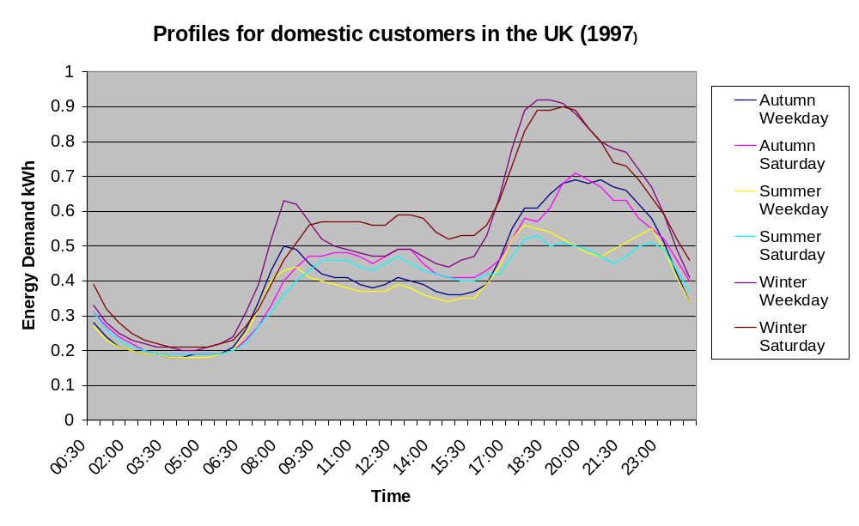
Figure 7 Average electricity demand of a domestic property as predicted by the settlement profiles.

Profiles in Ashton Hayes
In Ashton Hayes, as an example of how electricity load profiles can be studied, the load profile for one feeder was provided by the local distribution network operator. Residents also used Wattson monitors in individual homes as described above.

Three times of year were selected to look at the likely generation output and demand. Different combinations of generators were selected to find a mix that minimised import and export from the microgrid.

Matching Generation to Demand
Having assessed the demand profile, the next step is to consider the ‘best fit’ of generation to match that demand.

Output from monitored wind turbines and the local wind speed was used to estimate the output from wind turbines in Ashton Hayes.

The output from photovoltaics is more predictable (they don’t operate in the dark!). The maximum output will be in midsummer and the minimum in mid winter. Nevertheless, some areas are cloudier that others and a more accurate estimation of output should take the orientation, pitch and shading into account. The output from a PV panel in early summer (close to the longest day) and in winter is shown in Figure 8.
Output from a PV panel in Winter and Early Summer
0.0
0.1
0.2
0.3
0.4
0.5
0.6
0.7
0.8
0.9
00:05
06:45
13:25
20:05
02:45
09:25
16:05
22:45
Time
kW
PV
early
summer
PV
winter
Figure 8 Output from a PV panel in summer and winter

By subtracting the half-hourly outputs of different combinations and sizes of generator from demand, a combination that has a high probability of supplying the base load and some of the peak demand can be found. In the majority of situations, there are likely to be times when the generation is producing more electricity than is needed by the local load as well as times when the generation produces less electricity than is consumed locally.

In designing the appropriate generation mix, there is a balance to be struck between supplying as much of the load as much of the time as possible and exporting large amounts of power to outside the microgrid. The options available will vary from community to community but some of the factors that will need to be considered are:
- The physical space available to install the generation;
- The cost of different types of generators;
- The anticipated capacity factor/s; and
- Any subsidies that may be available for renewable energy generation (discussed further in Section 17.1.2).

Determining heat load
In some cases, it may be appropriate for a microgrid to provide heat to some or all of the buildings within its network. The heat may be a by product of electricity generation, in the case of CHP, or it may be generated separately via a biomass boiler. Ground source heat pumps (GSHP) can also be used. It is important to bear it mind, however, that a GSHP will increase the overall electricity demand and to factor this in accordingly.

If the electricity is needed from a CHPunit is needed in summer, the heat must be stored during the summer. A large underground heat store will be required for this seasonal storage.

Schools and other community buildings are ideal for CHP as they often have large continuous heating loads at one location. Retro fitting district heating to supply heat to a number of small loads such as houses is very costly.

For a large building, as well as the pattern of usage, it is important to establish the maximum heat required. The following steps detail how to calculate the heat demand:
- Using the cumulative energy billings, the number of kWh of heat used is calculated.
- Using weather data, the sum of the assumed temperature of the building minus the average temperature each day (dt_{d}) gives the total temperature rise required over a year (dt_{y}).
- Dividing the total kWh of heat by the dt_{y} gives the kWh per degree of temperature rise (U/dt)
- Multiplying U/dt by dt_{d} for each day gives the kWh required each day.
- Dividing this by 24 gives the average kW (P_{d}) for each day
- The maximum U_{d} gives the maximum heat demand required of the system.

The heat demand may be reduced considerably by improving the energy efficiency of a building. New boilers and CHPunits are generally more efficient than old units and therefore the power demand of new equipment may be lower. This can be taken into account by:
- Multiplying the maximum demand by the (estimated) efficiency of old heating units to get U_{heat}
- Dividing U_{heat} by the efficiency of the new unit to obtain U_{heatnew}

Ashton Hayes School
In the Church Road area, a large heat demand is the school. It is also in need of a new heating system and it therefore seemed appropriate to consider the microgrid providing heat for the school. It is known that each year Ashton Hayes school uses around 12500 litres of oil for heating. The calorific value of the oil is between 10 and 12.3 KWh per litre. Using weather data from 2006, and the method described above, the kWh used each day and the maximum kW required are calculated (Table 3). The excerpt from the spreadsheet shows that the maximum heat load is between 74kW and 90kW depending on the calorific value of the oil. The average heat load is between 20 and 25kW. If the efficiency of the boiler is low, the actual heat demand may be lower than this. Assuming a 75% efficiency, the maximum heat demand is between 44kW and 68kW. If a new heating system is 85%, the energy requirement is between 52kW and 80kW.

Table 3 Calculation of heat deand for the school
 |  |  |  |  |  | 12.3 kWh/l | 12500 | l used | 10 kWh/l | 12500 | l used
 |  |  |  |  |  |  | 153750 | kWh used |  | 100000 | kWh used
365 | days | 12.3 Kwh/l |  | 10kWh/l |  | Sum_{dT} | 1752 |  | Sum_{dT} | 1752
 | dT | kWh/day | kW | kWh/day | kW | Q_{target} | 215250 | kWh | Q_{target} | 140000 | kWh
01/01/06 | 8.49 | 1042.8 | 43.4501 | 678.2 | 28.26023 | UA | 122.90 |  | UA | 79.93
02/01/06 | 11.22 | 1379.2 | 57.46764 | 897.1 | 37.37733
03/01/06 | 8.00 | 983.4 | 40.97517 | 639.6 | 26.65051 | Q_{check} | 215250 | kWh | Q_{check} | 215250 | kWh
04/01/06 | 12.46 | 1531.0 | 63.79367 | 995.8 | 41.49182
05/01/06 | 12.24 | 1504.7 | 62.69488 | 978.7 | 40.77716
06/01/06 | 12.53 | 1539.8 | 64.15638 | 1001.5 | 41.72772
07/01/06 | 12.61 | 1549.5 | 64.56175 | 1007.8 | 41.99139
08/01/06 | 13.24 | 1626.8 | 67.78344 | 1058.1 | 44.08679
09/01/06 | 11.25 | 1382.3 | 57.59566 | 899.1 | 37.46059
10/01/06 | 5.47 | 672.6 | 28.02441 | 437.5 | 18.22726
11/01/06 | 7.10 | 872.5 | 36.35599 | 567.5 | 23.64617 | daily mean energy | 590 | kWh | daily mean energy | 382 | kWh
12/01/06 | 9.84 | 1209.5 | 50.39487 | 786.7 | 32.77715 | daily max energy | 2170 | kWh | daily max energy | 1411 | kWh
13/01/06 | 7.00 | 860.5 | 35.8546 | 559.7 | 23.32007
14/01/06 | 8.31 | 1020.8 | 42.53267 | 663.9 | 27.66352 | daily mean power | 245 | kW | daily mean  energy | 16 | kW
15/01/06 | 9.05 | 1112.7 | 46.36242 | 723.7 | 30.15442 | daily max power | 90 | kW | daily max power | 59 | kW
16/01/06 | 7.63 | 937.8 | 39.07629 | 610.0 | 25.41547
17/01/06 | 7.54 | 927.1 | 38.62824 | 603.0 | 25.12406 | boiler efficiency
18/01/06 | 4.33 | 531.8 | 22.1571 | 345.9 | 14.41112 | 75%
19/01/06 | 3.65 | 448.8 | 18.70072 | 291.9 | 12.16307 | heat demand | 68 | kW |  | 44 | kW
20/01/06 | 6.46 | 793.7 | 33.0703 | 516.2 | 21.50914 | new boiler efficiency | 80 | kW |  | 52 | kW
21/01/06 | 7.82 | 961.4 | 40.05773 | 625.3 | 26.05381 | 85%
22/01/06 | 12.57 | 1544.9 | 64.36973 | 1004.8 | 41.86649

Storing heat
If there is a heat store included and a low or no heat is required at certain times of the day, the heating can be run and the heat can be stored. The heat can be used to provide all or part of the heat load at times of maximum demand. In this way the size of the heat source (boiler or CHPunit) can be reduced. It also allows the boiler or CHPunit to run at full load and for longer periods which is generally more efficient. Heat stores are discussed further in section 12.

Connection to the Public Network
Most small-scale generation can be installed to run independently of the public electricity network or connected to it. To run completely independently, there must be sufficient generation and storage to supply all of the load all of the time. In addition, the regulation of the system will be more complex to ensure that the quality of supply is of a high enough standard. This is an additional cost that provides very little additional benefit unless the microgrid is situated in a remote location with an unreliable electricity distribution system.

For most locations it is advisable to connect to the public electricity distribution system. This allows excess power to be exported and a deficit in generation to be met by generation elsewhere. In addition, if the local generation fails or is out of action for maintenance, there is still a source of power.

Connections to the public distribution system are controlled by the distribution network operators (DNOs) who own and operate the systems.

Anyone wishing to connect to the distribution network must pay for the additional equipment to allow this to happen. If some equipment is shared between different generators connecting to the network, then these costs may be shared according to ‘cost apportionment rules’ but this is unlikely for a connection to the LV network. Some connection design and installation work can be carried out by approved contractors rather than the DNO. Once the installation work is completed, the DNO will ‘adopt them’ and own and maintain them. All design work by third parties must be approved by a DNO. The DNO will make a connection offer detailing the terms and conditions of the connection with which the generator must comply. This offer is normally valid for 3 months.

When applying for a connection to the network, the maximum capacity of the generation must be given. If it is expected that a microgrid may be extended and generation may be added at the same point, it may be more cost effective to apply for a larger capacity initially and purchase equipment rated for the additional capacity initially. Replacing equipment at a later date and applying for a further connection to the network will be more expensive. If additional generation will be connected at a different point however, this does not apply.

An example of the likely cost for a connection at 230V that requires 100m of new line to the existing distribution network is around £5-10,000. There will be some additional charges, for example for the DNO to carry out the design and for any way leaves (rights to take a connection across land). For an installation that is already located at the distribution network (for example for photovoltaics on a house), the cost of building a connection to the network will be avoided.

By connecting a number of generators at the same time, the connections can be co-ordinated and the costs of design and installation can be reduced. In addition, alternative connection designs can also reduce costs.

Individual generators that are smaller than around 4kW can be connected to the network if they are designed to G83/1 industry standard and installed by an accredited installer without prior permission. The DNO must then be informed through a standardised process (requiring sign off by a registered installer). It is however likely that a community would want to connect larger generators or a cluster of generators for which the G83/1 standard does not apply. These must be designed to the G59 industry standard.

Figure 9 below shows the different components that are required for the connection of a small generator. Conventionally each generator has its own invertor however cost savings can be made by connecting a number of generators through one invertor. EA Technology has been liaising with a developer of such an invertor.

The shaded boxes indicate equipment that can be in more than one position.

Controller for turbine
2,3or 4 phase connection
G59 protectionprotection
invertor
Supply meter
ROC meter
Distribution board MCB
Distribution board MCB
ROC meter
Service cable
Board fuse
Joint in street
PV panel
G59 protection
Controller for PV
DC
Synchronous gen
Needs a synchronisation check for synchronous generator.
If the generator is connected to distribution board that also serves load then the G59 protection should be between the board and the generator. Otherwise a false trip will also trip the load. For a board with only generation connected, the protection can be on either side of the board.
Figure 9 Diagram of the components of a connection of a small generator to the public network.

A building can only have one supply point and therefore to be able to meter generation and demand (as well as net power flow) the generation should be connected via a separate distribution board (preferable outside the building) and separate service cable (Figure 10). This lends itself well to the concept of one point of common coupling for a number of generators. The only alternative to this would be to have 2 connections into a single distribution board – one for the load and one for the generation (Figure 11). The meters would need to be situated before the load and generation are connected to the board. This type of connection may not be possible and the distribution board may need to be replaced and therefore a separate board may be as cost effective.

Half-hourly meter
Half-hourly meter
Load Distribution board
Generation
Load
Public network
N
R
Y
B
Generation Distribution board
N
R
Y
B

Figure 10 Generation and load connected through separate distribution boards.

Half-hourly meter
Half-hourly meter
Distribution board
Generation
Load
Public network
Y
B
R
N
Figure 11 Generation and load connected through a single distribution board.

If a single invertor is used, it is important that the generation from each source is metered separately for ROC purposes.

A Focus for the Microgrid in Ashton Hayes
The school has a large roof that could be used to mounted PV, it is close to the field where the wind turbines may be located and may be using heat from the CHP unit. It could therefore be the hub for a microgrid with a number of generators connected together through one invertor as described above. It is also expected that there would be a separate meter and disitrbution board as described above.
There is also the potential to reduce costs by
- using the same equipment,
- having one rather than many connections,
- reducing installation costs.

Metering
Meters are used to capture the amount of energy or heat produced or consumed. The majority of meters used in the UK at present for small consumers are cumulative (i.e. they will just keeping counting units (almost) indefinitely and are used to calculate how much energy has been consumed. They do not record how much energy was used at a particular time of the day.

The suppliers have to buy power for each half-hour in advance. The amount they pay for power at times of high use is greater than at times of low use even though they charge a flat rate to domestic customers. In addition, the amount of carbon emitted per kWh of electricity is generally higher at times of high demand compared to low demand.

Suppliers do not know exactly when their domestic customers will use power and therefore they estimate the amount used by each customer over a day using standard profiles. These estimates are carried over many thousands of customers within a large area. The difference between what each customer used and the profile is therefore smoothed out over many customers. The overall error between what is actually used and the prediction is shared between all the suppliers within the area in proportion to the number of customers that they have in the area. There are two profiles for domestic customers depending on whether they use Ecomony 7.

The system of estimations against standard profiles means suppliers have no facility to charge customers different prices depending on when they use the electricity. There is no means for a supplier to encourage customers to reduce their individual demand during times of high overall demand when the price that suppliers pay for the electricity is high and the carbon emitted per kWh is higher than average.

The use of Smart Meters for small consumers was introduced in the Energy White Paper in 2007 and the Energy Act 2008 granted the Secretary of State the powers to amend supply licenses in order to introduce such meters. The capabilties of a Smart Meter are yet to be finalised but amongst other attributes it is expected that they will be able to:
- record how much energy is used in each half hour,
- be read remotely (i.e. without a visit from a human being),
- be able to display how much energy is being used when,
- switch from pre-payment to post-payment
To date, arrangements for a rollout for domestic properties is being finalised.

Meters are also used to measure how much electricity is generated. Presently, generators over 30kW must be metered on how much they produce on a half-hourly basis. Small generators (up to 30 kW) can opt to sell their power against an assumed profile (like domestic customers). The cost of half-hourly metering and its operation for small generators is in the region of £150-200 a year.

For a community energy scheme, in order to demonstrate how much locally produced energy is consumed locally, half-hourly metering is needed to demonstrate in any half hour how much generation was consumed by the community (and whom within it). A community will need to know this information as any deficit in power consumed by the community or surplus power generated must be bought or sold with a licensed supplier. Half-hourly metering is particularly relevant if the community intends to differentiate the price charged to the community based on whether the power consumed is locally produced electricity or imported from a licensed supplier.

The cost of a Smart Meter for a domestic customer at present is around £85. However it is expected that once they are standardised and mass produced they will cost around £40-50 which is similar to the present non-half hourly meters. There are a number of ways of reading meters such as mobile text messaging, radio signals or using the Ethernet. For trials that have been carried out recently mobile text messages have been used, however once the meters have been rolled out across a region other methods may be used. The cost of communication via text messaging is around 3p-4p per message with one text able to send a day’s worth of data.

As well as allowing half-hourly metering, Smart Meters should give customers greater awareness of the power they are using (or wasting) and its cost. Trials of meter displays and accurate bills have shown that this reduced customers usage significantly.

Demand Side Management Technologies
In order to match load and generation, it is important to be able to move load to different times of the day as well as try to match the generation to the demand. Residents may not be available or necessarily aware of when to switch load on or off and therefore manual switching will not be very effective. Thus, for DSM to be practical, loads need to be switched automatically.

There are a number of ways to implement automatic DSM. These can be divided into different categories:
- Time switches
- Devices to allow remote switching to turn off devices that are normally on.
- Devices to allow remote switching to turn on devices that are normally off. Generally there is a fixed period within which the load must be run but an optimum time(s) within the period can be selected.
- Devices that turn loads on or off if the frequency strays outside set limits.

Time switches are useful to run loads at a time when it is known that the average load will be low, for example during the night. If there is a large amount of photovoltaic generation, time switches could be used to ensure there is sufficient load during the day to match the generation. Likewise, if a CHP unit must be run at a particular time to provide heat, load can be switched on at these times. In general however time switches are difficult to use to match intermittent load and generation.

Devices that remotely switch loads off can be triggered if the load in an area is greater than the generation. In the case of a microgrid with all the generation and load on one feeder, measuring the power flow at the start of the feeder could detect when the load is greater than the generation. If there is significant power flow into feeder, the generation is less than the demand. This is the trigger to switch off loads. If the power flow reverses loads can be switched back on. There may be a time limit to the duration that a load can remain switched off. Preferably, load switching should be staggered to prevent sudden drops in power. To install such a system, the DNO would have to agree to allow the installation of a monitoring device on their feeder.

Devices that remotely switch on loads can be triggered if the load in an area is less than the generation. In the case of a microgrid with all the generation and load on one feeder, measuring the power flow at the start of the feeder could detect when the generation is greater than the load. If there is significant power flow up the feeder, the generation is greater than the demand. This is the trigger to switch on loads. The types of loads that could be switched on are dishwashers, washing machines, bread makers etc. For most of these types of load they will need to run within a set time period – for example within 24 hours. To install such a system the DNO would have to agree to allow the installation of a monitoring device on their feeder.

As the microgrid is connected to the public network, the frequency will be held steady. Devices that are triggered by changes in frequency would therefore not be appropriate for a microgrid.

There is no device specifically designed to turn loads off or on as described above however there are many systems that carry out similar tasks that could be adapted.

There are a number of systems to control loads on a site wide basis particularly for industrial sites that have highly developed energy management systems. Other manufacturers are focused more at the residential market. Although domestic systems concentrate on timers, motion sensors and security, some now also incorporate smart plugs that can be switched remotely. These would need to be triggered by a signal from a unit monitoring the power flow into or out of the feeder. Alternatively there are systems developed for utilities to manage their networks and monitor network conditions. In some case these are incorporating control of loads and small-scale generation. The choice of system will be determined by price and the level of control, accuracy and reliability required. The more expensive systems will allow logic programming for example to ensure loads operate during a set period. Cheaper systems are likely to have less reliable communications.

To signal to a building most systems use Ethernet connection through a PC or a mobile phone although other equipment designed for utilities can use radio signals. Hard wiring or wireless communication is used within a building.

At this stage it is sufficient to establish that there is technology available, the technologies used can be determined during implementation in negotiation with a DNO.

Energy Storage – Electrical and Thermal options

Benefits of Energy Storage
The models developed in this work aim to use as much energy as possible directly as any storage device reduces the efficiency of a system. However if load or generation cannot be moved to match each other it may be beneficial to store energy.

In the case of heat, if a low or no heat is required at certain times of the day, the heating can be run during those times and the heat can be stored. The heat can be used to provide all or part of the heat load at times of maximum demand. In this way the size of the heat source (boiler or CHPunit) can be reduced. It also allows the boiler or CHPunit to run at full load and for longer periods which is generally more efficient.

If the electricity and heat are required at different times of day, it may be useful to store heat or electricity to allow a CHP unit to be viable.

If it is not possible to move electrical load to a time when power is generated or find a mix of renewables that matches the load, it could be beneficial to use electrical storage. Storage should be considered as a last resort after attempting to match load and generation.

Storage can allow more power to be used locally (albeit with some power lost in charging and discharging the storage). Alternatively, if power is sold to a licensed supplier, storage can be used achieve a better price for the power. This can be achieved via either:
- smoothing the output and achieving a better price as a result.
- if the price for power is variable, storing the power at times when the price is low and exporting at a time when the price is high.

Heat Storage
The simplest form of heat storage is to heat hot water. This can be extracted for use in a heating system or for domestic hot water needs. Modern hot water cyclinders can be highly insulated. The water can be heated from CHP units, solar thermal or electricity. The thermal capacity of water is relatively low and therefore it is bulky to store heat for more than domestic needs via water. New phase change materials that store heat by changing from solid to liquid are less bulky and could make heat storage much more feasible, however they are not available ‘off the shelf’ and are still under development.

Ideally the storage is stratified so that the hottest temperatures are taken for most uses from the top stratum. If medium temperatures are need (for example for underfloor heating) these can be taken from a middle stratum.

If a CHP unit is to be electricity led (i.e. it operates when the electricity is needed), heat will need to be stored in summer in a seasonal heat store. Another source of heat for a seasonal heat store are solar thermal collectors for heating systems. Typically the heat is stored in boreholes, gravel many meters below ground level. The capital costs of boreholes are expensive. A 50kW store capable of supplying 120MWh of heat would cost around £110 000 including equipment and installation. Costs can be reduced by combining the work with other refurbishments.

Potentially a seasonal thermal store could be used at the school to allow the CHPunit to be run electricity led in summer.

Electrical Storage
When considering electrical storage, the losses in the system must be taken into account to establish whether a system is cost effective as well as the additional cost incurred for storage. These vary depending on the type of battery. Three possible types of battery that should be considered for load levelling are:
- Lead acid: these are the most well understood, oldest commercial battery and have low capital cost. However they have low energy storage, slow charge rates (around 10 hours) and only last for around 500-1000 cycles. Their efficiency is only around 75%.
- Lithium-ion batteries: there are a number of lithium technologies all of which are new technologies. They are 2-3 times as expensive as lead acid but can achieve around 2-3000 cycles, have efficiencies of around 95% and charge times of around 3 hours. As a result, although the capital cost is higher, over a lifetime they are more cost effective.
- Flow cells have two electrolytes that are kept separate allowing more control over the rate of discharge. They have long lifetimes and short charge rates as their electrolyte can be replenished. Electrical storage is only limited by the amount of electrolyte. They also can provide a very high power output. However they are very costly and have efficiencies of around 80% and so there have been few installations.

Typical price for a 100kW lithium-ion battery is around £25-27 000 and lead acid batteries are around £9-15 000. In addition, a control system to integrate the storage and renewable generation is required.

Battery specification
In specifying a battery, the following information is needed:
- the maximum power needing to be stored
- the maximum energy needed
- depth of discharge
- number cycles a day or week

It is important that a battery system is well designed by specialists.

It is not envisaged that electrical storage would be used at Ashton Hayes.

Size and Extension to a Microgrid
This initial study is for one feeder or road in Ashton Hayes. This was chosen because it was easily definable electrically and geographically and for trial it is a manageable size. However the microgrid could be extended to the rest of the village.

An objective of the village may be to invest some of its income to extend a microgrid. Future plans should be considered right from the start however as it may be more cost effective to install larger generation capacity from the outset. Alternatively the village may wish to apply for a connection agreement with a larger capacity than is initially connected so that further generation can be added later. This may be cheaper than making two applications and having to replace equipment (see section 9).

Commercial Model for the Generation
This section tackles the issues associated with developing a new commercial model for the treatment of energy generated and used within a community in the UK. It is based on the development of a specific type of Community Energy Service Company (ESCO) that has been tailored towards this type of scheme.

The term ‘energy’ is used, unless the discussion is specific to electricity or heat, as the model has been developed to be suitable for use with renewable heat, as well as renewable electricity schemes. In the Ashton Hayes Microgrid is primarily for electricity but it is anticipated that the ESCO will sell heat to the school. Most of the comments relating to the regulations concern electricity only. The regulation of the electricity industry is a highly complex framework, whereas the supply of heat is largely unregulated at present.

The suggestions in this section have been discussed with one of the focus groups set up in Ashton Hayes and their feedback has been useful in identifying the issues that are likely to concern a community, as well as identifying what a community might be able to do for itself. This is supported by EA Technology’s knowledge and experience of the energy industry to recommend a model which could allow a community to maintain as much control as possible, without individuals becoming swamped by the day-to-day responsibility of operating such a scheme.

The requirements for this model differ from other community energy schemes as it has been designed to use the public distribution network and act as an unlicensed supplier and will therefore need to operate within the rules that govern this. It is unlikely to be entirely self-sufficient all of the time, with times when it will need to export electricity to a licensed supplier and times when it may need to import from them. It will therefore need to work within rules of the Balancing and Settlement Code (as discussed 6.2).

Background to the Model
In developing this model, there were a few requirements that were fundamental in order to enable communities to take control of their energy use and to maximise the benefit to any community adopting the model. These are:
- The community or members of it should own the generation;
- Incentives should encourage as much as possible of the locally generated power to be used by the community;
- The community should be empowered to make decisions about how the energy it produces is shared between its ‘members’; and
- The model should be simple, workable, inclusive, replicable and sustainable.

As the work progressed, there were some further requirements that were added to this list in order for the model to be adopted within the existing regulatory framework (as far as possible), and to ensure that it could be replicated by other interested communities. These were:
- Generation equipment should be owned by the community as a whole, rather than by individuals within it;
- Households and businesses within the Microgrid area should be able to choose to ‘opt-in’ to buying their energy from the community or to maintain the existing arrangements with a licensed supplier, in order to preserve consumer choice; and
- A number of communities developing the model should be able to work together to use economies of scale to minimise their overheads and thereby produce energy at the lowest cost possible.

There are a number of reasons why the model is based upon the generation equipment being owned by the community as a whole. It is likely that a community would find it easier to finance the project through accessing grants and other funding streams that are available to community organisations, rather than to individuals.

Some properties within a community are likely to be more suitable than others for locating the equipment. If the equipment belongs to the community as a whole, the whole of Ashton Hayes will feel able to participate.

Finally, and most importantly, the regulatory framework prohibits a property from having more than one licensed and one unlicensed supplier of electricity. This effectively prevents individuals from trading electricity between each other. By owning the generation communally, the Ashton Hayes community becomes the one unlicensed supplier for everyone which addresses this potential problem.

Relationship between the CORE and a Generator Host
In order for the Community Organisation for Renewable Energy (CORE) to own generation that is located on a building or land owned by a member of the CORE a contract would need to be in place between the owners of the building and land and the CORE. This might be similar to arrangements for telegraph poles of electricity poles or cables on people’s land. The contract would need to specify clearly how insurance and maintenance would be carried out. Such arrangements would need to be declared if a building or land is sold. It is envisaged that a generic framework could be developed.

The Community ESCO model (CORE)
The model developed for how a community ESCO would operate is illustrated in Figure 12. The focus group looking at these issues adopted the term CORE as a name for this community organisation and to distinguish it from other ESCOs. The term CORE is therefore used throughout the remainder of this report to describe a community ESCO that operates in line with this model.

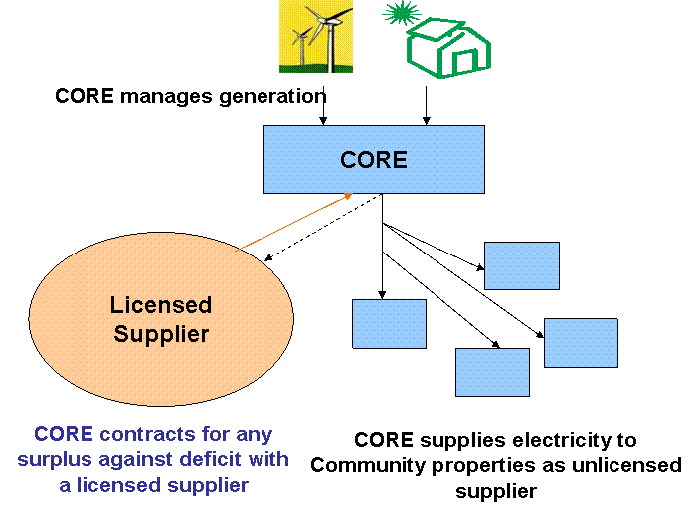
Figure 12 Interaction between CORE and a Licensed Supplier

To minimise the inconvenience to the customer, the CORE would act as unlicensed supplier to those members of the community that choose to ‘opt-in’ and buy their energy from the CORE and would be ultimately accountable to the community for its actions. It would therefore be responsible for
- agreeing the terms with a licensed supplier (for buying additional power required by the community and selling surplus generation),
- agreeing a price tariff for the community,
- billing the customers.

An unlicensed supplier (e.g. the CORE) could not organise the meters itself as metering is a regulated activity. A Meter Operator Agent must organise the meters on behalf of a licensed supplier that is entitled to register meters, as laid down by the Balancing and Settlement Code. Once OFGEM’s proposals for licence modifications for ‘second tier’ schemes enter into force (as discussed in 6.2), it is anticipated that the licensed suppliers will begin to offer services such as metering as part of the services they offer to ‘second tier’ suppliers. The terms for such services could form part of the agreement with a licensed supplier.

It is important that the CORE is accountable to Ashton Hayes and Figure 13 shows the accountability that would need to be in place between the members of the community (grey triangles) and the CORE. This diagram also introduces the concept of a Services Agency, which could be set up to support communities developing this model.

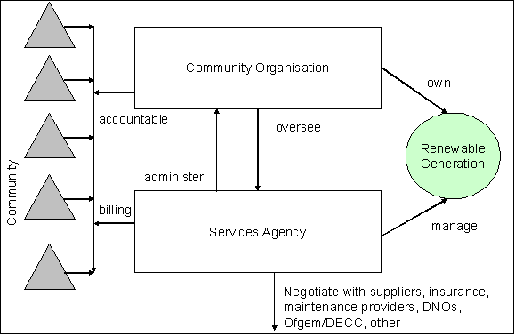
Figure 13 Interaction between CORE, community and Services

The Services Agency would manage the renewable generation on a day-to-day basis on behalf of the community and deal with the majority of administrative tasks, including management of maintenance work, processing of bills and payments; and interaction with suppliers, DNOs and other industry bodies. Unlike the CORE, which would be specific to each community, the Services Agency could provide these services to a number of communities (e.g. many villages such as Ashton Hayes) that have adopted the model, as illustrated in Figure 14.

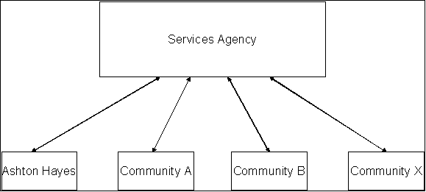
Figure 14 Interaction between Services Agency and multiple communities.

It is anticipated that the use of a Services Agency will increase the number of communities that would be capable of using this approach. The degree of interaction between the CORE and the Services Agency could, for example, even be varied to reflect the needs of each community depending on the resources that are available within it, such as time and existing knowledge. The Services Agency should prevent the renewable energy project over-burdening individuals within a community as well as helping to ensure the long-term viability of the model as it is not impacted by changes within a community, such as individuals moving in or out.

The Services Agency would operate in a similar way to a facilities management organisation, providing specific services to the communities on a contractual basis and thereby minimising the overheads to which any one community would be exposed. The costs of maintaining a customer service helpline, for example, at times that are likely to be convenient to all the stakeholders within a community is likely to significantly outweigh the use of such a service. However, it is a service that many people would look for when making choices about where to purchase their energy. Sharing that cost across a number of communities would offer a cost-effective and workable solution.

An additional benefit to using a Services Agency in the model is that it can offer a degree of protection and privacy to members of the community that choose to ‘opt-in’. Individuals may worry about a neighbour processing their financial details as part of the payment process if the CORE undertook this task. Any concerns or disputes over bills or any other aspects of the service would be with a third party so should have minimal impact on community relations.

An example of the tasks needed to set up a CORE is provided in Appendix IV (this is not intended as an exhaustive list). Most of these are standard for setting up a legal organisation and a Services Agency could provide assistance. Appendix V lists ongoing tasks and demonstrates how most of the tasks can either be completely or partly carried out by a Services Agency.

Establishing a CORE
The following is a list of questions that a community needs to consider when contemplating setting up a CORE:
- What type of organisation should it be? Should it be a charity?
- What will be the rules of the organisation? For example, how can people be involved and how are people appointed to roles within the organisation? These rules are likely to form the basis of a Constitution or Articles of Association document, depending on the type of organisation that is set up.
- How will it interact with other groups/organisations within the community and beyond?
- How much time will be required to run the CORE, both day-to-day but also in terms of committee meetings etc? Are there people that are willing to commit to doing this?
- Who does the organisation need to be responsible to? (In most communities, this is likely to be the community itself but there may also be a need to be accountable to a funder, local council or other bodies that are stakeholders in the project).
- Is there support available if something changes or there is a problem?

The use of a Services Agency, as outlined above, could resolve some of these issues for the community but they should still be considered as part of that decision.

The following points provide generic information on these topics and do not replace professional, legal advice. It is hoped that, as part of the implementation in Ashton Hayes, framework documentation for the establishment of a CORE can be developed that could be used by other communities (discussed below in section 19).

Types of Organisation
Presently, CORE is used as a generic term to describe any organisation that is run by, or for, a community with its main focus being to install and operate renewable generation. There are, however, a number of different types of organisation that could be used to establish the CORE. It is important that the legal framework reflects the community’s goals and priorities for the organisation, as well as ensuring everyone knows the rules by which the CORE will operate.

Limited Company
This is the most frequently adopted corporate structure. It can be limited by shares or guarantee and will look slightly different depending upon which approach is taken. It is a relatively flexible model that can be adapted to fit most circumstances.

Social Enterprise
Social Enterprises are businesses set up to tackle a specific social or environmental need, with profits made being reinvested back into the business. They can be private companies (as discussed above), cooperatives (see below) or Community Interest Companies (CICs).

Community Interest Company
CICs are a relatively new model for limited companies that wish to operate for the benefit of the community, rather than shareholders. There are a number of clauses that must be included in the organisation’s constitution (or equivalent) and which are subject to stricter than normal rules on the treatment of assets. They are regulated by the CIC regulator to ensure that they do not deviate from this model and more information can be found on the regulator’s website.

The legal model for a CIC has been specifically developed for social enterprises to provide a quick and easy model for setting up this type of organisation. Templates for the documents required to set up a CIC are available from the regulator’s website to minimise the inconvenience. It also has the benefits of being based on the basic company model which is known and understood in the business world, whilst safeguarding the company’s assets to ensure they are used for the community’s benefit.

Co-operative
The International Co-operative Alliance defines a co-operative organisation as "an autonomous association of persons united voluntarily to meet their common economic, social, and cultural needs and aspirations through a jointly-owned and democratically-controlled enterprise".

There are seven key principles that an organisation must abide by to be considered a cooperative (Voluntary and Open Membership; Democratic Member Control; Member Economic Participation; Autonomy and Independence; Education, Training and Information; Co-operation among Co-operatives; and Concern for Community). Further information on co-operatives can be found on the Co-operatives UK website.

Development Trust
The Development Trust Association defines development trusts as “organisations which are engaged in the economic, environmental and social regeneration of a defined geographical area.” Whilst they are referred to as Trusts, there is no standard legal form for the organization and they can use one of the other legal forms discussed above. Further information is available from the Development Trust Association.

Charitable Status
Setting up a CORE so it is eligible to be registered as a charity is definitely not an ‘easy’ option. There is a specialised body of law that charities must comply with and, in some ways, the rules for charities regarding running, organisation and accounting are more stringent than for other organisations. There are however a number of benefits that charities can be eligible for which may be sufficiently beneficial to a scheme to outweigh the additional obligations.

Charities, for example, are eligible for tax relief on most income or gains, including profits from certain activities. Interest on bank/building society accounts, for example, should be paid ‘gross’ (i.e. without tax deducted) for charities. Similarly, donations made to a charity by taxpayers are eligible for ‘Gift Aid’ whereby the charity can claim back the basic rate tax paid by the donor for the money donated. Finally, the profits of charities that carry out trading activities as part of meeting their ‘Primary Purpose’ are generally exempt from tax. Further information is available from the Charity Commission.

The Charities Act 2006 introduced a new form of organisation, the Charitable Incorporated Organisation (CIO), aimed at charities that wish to be set up with a corporate structure. A CIO would only need to be registered with the Charity Commission, making the reporting requirements a bit easier as the need to report separately to Companies House would be removed. The detail of the rules for such organisation is currently being consulted on by the Government but may be a workable alternative to some of the types of organisation discussed above.

Rules for the CORE
Whatever type of organisation is adopted, it is important to ensure that the ‘rules’ for the organisation incorporated in the Constitution or Articles of Association (or equivalent) are appropriate for the community’s goals. These will cover things like who can be a member/shareholder of the organisation, who can be a director, how often elections for directors are held, how the organisation makes decisions, etc. Some of these decisions will be determined by the type of organisation that the community decides the CORE should be.

Accountability
This model is based on establishing a CORE that is accountable to Ashton Hayes, as owners of the generation equipment, for how that equipment is managed and maintained and for how the energy it produces is distributed. There may be other stakeholders that the CORE will need to be accountable to, such as finance providers, local councils, etc.

The type of legal structure that is adopted may determine how that accountability operates. A limited company, for example, would be accountable to its shareholders whilst a co-operative would be accountable to its ‘members’. It is likely that the Constitution or Articles of Association adopted will outline how a CORE is accountable but it is important to ensure that the community understands how this will work.

Interacting with other Groups/Organisations
As Ashton Hayes has a number of other groups already in place (e.g. the community shop), there may be significant benefit in bringing these groups together to gain the most benefit for the community as a whole. This is also likely to reduce the overall time commitment required by individuals which is an important consideration when working with volunteers.

When combining community groups care should be taken that a few individuals don’t become overburdened. There are also specific concerns if one (or more) of the groups within the community has charitable status as they may have different objectives. Whilst charities can have some activities that are peripheral to their main objectives, there are limits to such activities.

One solution may be to have an overriding community organisation such as a community trust or parish council. This could then have a number of subsidiary organisations that have more specific goals such as managing the community buildings, running the village shop/post office, and operating a CORE.

Establishing a Support Network
Establishing relationships with professionals will provide appropriate support, advice or services is likely to ensure the long-term sustainability of the scheme. Ashton Hayes has already laid the foundations for this with Chester Univeirsty and EA Technology.

It is also expected that Leapfrog with provide pro bono legal services to find the most appropriate legal status for the CORE in Ashton Hayes and draw up contracts and a constitution.

The use of a Services Agency would enable a community to tap into a established network and one that other communities adopting the model could access.

The Economics of a CORE
The costs and income from a microgrid are very hard to predict in the present economic climate. Not only does the price of oil, steel and silicon have a significant impact on the cost of generators and photovoltaic panels, but there is uncertainty over how the introduction of feed-in tariffs will affect the income from such a project. The Energy Act 2008 granted the Secretary of State the power to amend licence conditions for suppliers and/or DNOs to facilitate the use of feed-in tariffs. Instead of the present subsidy through ROC that can vary in price, a feed-in tariff would provide a flat rate incentive for all power generated or exported. Whilst it is generally expected that these will be introduced for “small scale low-carbon generation”, the first consultation on the details of how feed-in tariffs may operate is likely to be published this summer. Similarly, the Government has proposed to introduce a renewable heat incentive and is currently consulting on how this might be operated as part of the Heat and Energy Strategy consultation. These mechanisms are further described in section 17.1.2. In addition, in the next few years, smart meters will be introduced to domestic properties. It is unclear what impact this will have on the costs of implementing a community renewable energy scheme or on the energy market.

Unlike most traditional methods of generating electricity like coal or gas, the majority of renewable sources do not have an associated fuel cost so many people think of renewable energy as being ‘free’. However, any generation scheme will face a number of costs that will need to be recouped from somewhere. It is anticipated that a scheme will be able to offer lower energy prices than those normally available but the energy generated will have a cost associated with it.

The following sub-sections provide an overview of the possible income streams and ongoing expenditure for Ashton Hayes.

Income streams

Selling power
The first sources of income to be considered are from the supply of electricity and heat generated by the CORE’s generators. These should be considered as the main income streams as subsidy schemes for renewable energy are more uncertain and subject to change as described above. Whilst supplying of heat will only be to local residents and buildings, electricity is likely to be sold both to those who opt into the CORE and to a licensed supplier as outlined above.

Ideally the price for power sold to those who opt into the CORE should be greater than the price that the CORE can sell power to a licensed supplier but less than the price at which domestic customers buy from a licensed supplier. This will provide savings for members of the CORE but also more income for the CORE than if all the power was sold to a licensed supplier. The CORE may decide to charge particular sites a lower price (for example the village hall or school). By using half-hourly metering, the CORE may charge a different price per kWh at different times of day or for locally generated power rather than power imported from a licensed supplier.

Renewable energy subsidies
The second possible source of income is through the ROCs scheme. The renewable obligation certificate (ROC) is a support mechanism for each MWh of renewable power generated. The large licensed suppliers are obliged to provide an increasing percentage of their power from sources that have these certificates or pay a “buy-out” or fine. The money from any fines is distributed to those who have certificates. Suppliers buy ROCs from renewable power generators and there is a market in the certificates. Suppliers who have more certificates than they need can sell to those who do not have enough. The minimum price for ROCs is the “buy-out” price set each year by OFGEM. The market price of the ROCs is higher as money from the “buy-out” is distributed to those with ROCs. ROCs are issued for all renewable electricity generation (not just that exported to the public network).

The number of ROCs received by different technologies varies.
Small wind (under 50kW) 2 ROC/MWh
Onshore wind (>50kW) 1 ROC/MWh
Photovoltaics 2 ROC/MWh
Hydro<50kW 2 ROC/MWh
Biomas CHP 2 ROC/MWh
If generation is connected through a single invertor to the public network, the different sources will probably need to be metered separately for ROC purposes.

OFGEM is responsible for issuing ROCs, as the administrator of the Renewables Obligation. They can then be sold on, either as part of a contract with a licensed supplier or can be auctioned on-line. There is an administrative cost for using the electronic auction facility. Note also that the price for ROCs on the auction may go up or down. Alternatively, an agent can be employed to aggregate ROCs from a number of small generators and this aggregation could also be performed by the Services Agency.

As discussed above, legislation to allow the Secretary of State to introduce a feed-in tariff for electricity generation under 5MW has been passed but further details have not yet been published. This could be a simpler system than claiming ROCs for small renewable generators, depending on the terms. It is also likely that a renewable heat incentive will be introduced but there is very little information available on this at present. It is very unlikely that a CORE could claim both ROCs and a feed-in tariff, however a renewable heat payment could probably be combined with one of these but this will depend on how the schemes operate and interact.

Ongoing Expenditure
As highlighted above, there is often a misconception that renewable energy is ‘free’ but the CORE will need to deal with the following types of expenditure and allow for these when setting its budgets and deciding on how to price the energy.

The first thing to consider is the capital costs associated with setting up the scheme. These will include the purchase of the generation equipment and establishing a connection to the public distribution network. The costs of the generation equipment will obviously depend on final details of the scheme as will the cost of connection to the network.

The financing arrangements for the purchase of the generation equipment are likely to create an ongoing expenditure for the CORE. Finance, other than in the form of grants, will usually need to be paid back along with interest on the money borrowed. The terms of this agreement are likely to be critical in many situations as to whether or not the scheme is viable. If Ashton Hayes intends to extend their scheme at a later stage by purchasing further generation equipment, it may also wish to put some money aside towards such expenditure.

For the times when there is insufficient locally generated power, the CORE must pay for power from a licensed supplier. This is likely to be offset against the value of the electricity sold to the licensed supplier but the value of the import and the export may differ, depending on the terms of the agreement. It is likely the price at which a supplier is prepared to sell power to the CORE will be higher than that at which it is prepared to buy. It may also charge more for electricity at the peak times as this is when it is most expensive for the supplier. This will be an added incentive for CORE members to move the load to when the CORE’s generation is operating and away from times of peak power use.

If the scheme incorporates any generation that is run off a fuel (such as biomass or biodiesel), there will be an ongoing cost associated with purchasing further supplies of the fuel.

The day-to-day administrative costs of running the business, such as processing bills and payments, bills for professional advice (i.e. lawyers, accountants, etc) and dealing with any queries will need to be covered. Under the model described, it is anticipated that these services would be provided by the Services Agency but there would be a cost associated with such services.

Finally, Ashton Hayes will need to allow for the costs of maintenance. This may not be a significant cost in the early years as many manufacturers will cover this cost as part of a warranty, or equivalent, but should still be borne in mind. It may also be possible to agree a maintenance contract, for example, where a flat fee is payable for up to a set number of call-outs in any one year. It is anticipated that maintenance would be one of the services provided by the Services Agency and therefore form part of that agreement.

Ashton Hayes
This section provides a Best Case and Worst Case scenario for the income for the scheme currently being proposed for Ashton Hayes and with the information on ROCs that is currently available. It does not include Feed-In Tariffs or the Renewable Heat Incentive as there is not yet sufficient information on the schemes to build them in to the example. It does not differentiate between the price of electricity that could be sold to those who opt-in to the scheme and the price for power sold to a licensed supplier.

Best Case
This assumes that
- cost of biodiesel for the CHP unit is £0.5/litre,
- electricity from the CHP unit can be sold for £0.08/kWh and £0.08/kWh can be claimed in ROCs (or equivalent).
- heat from the CHP unit is sold at £0.035/kWh
- electricity from the wind can be sold for £0.08/kWh and £0.08/kWh can be claimed in ROCs (or equivalent).
- electricity from the PV panels can be sold for £0.08/kWh and £0.08/kWh can be claimed in ROCs (or equivalent).

Allowing for the ongoing maintenance and fuel costs, this would result in an income of approximately £19,000 a year (as shown in Table 4), although it should be noted that this does not allow for any finance costs. It also does not allow for the costs of administering the scheme, whether done locally or contracted to the Services Agency.

Table 4 Best Case Scenario
Capex | £ | Opex | £ per year | income | £ per year
CHP | 35000
 |  | Fuel cost | 7200 | electricity | 8160
 |  | maintenance | 1500 | heat | 2730
 |  |  |  |  | 10890
heat store | 110000
PV 27kW | 108000
Wind | 80000
connection | 10000
invertor | 32000
 | 375000
 |  | maintenance | 500 | income wind | 13,455.36
 |  |  |  | income PV | 3784.32
 |  |  | 9200 |  | 28,129.68
 |  |  |  | net income | 18,929.68

Worst case
This assumes that
- cost of biodiesel for the CHP unit cost £0.96/litre,
- electricity from the CHP unit can be sold for £0.045/kWh and nothing can be claimed in ROCs (or equivalent).
- heat from the CHP unit is sold at £0.035/kWh
- electricity from the wind can be sold for £0.03/kWh and £0.08/kWh can be claimed in ROCs (or equivalent).
- electricity from the PV panels can be sold for £0.03/kWh and £0.08/kWh can be claimed in ROCs (or equivalent).

Table 5 Worst Case Scenario
Capex | £ | Opex | £ per year | income | £ per year
CHP | 35000
 |  | Fuel cost | 13824 | electricity | 2295
 |  | maintenance | 1500 | heat | 2730
 |  |  |  |  | 5025
heat store | 110000
PV 27kW | 108000
Wind | 80000
connection | 10000
invertor | 32000
 | 375000
 |  | maintenance | 500 | income wind | 10,406.88
 |  |  |  | income PV | 2601.72
 |  |  | 15824 |  | 18,033.60
 |  |  |  | net income | 2,209.60

Allowing for the ongoing maintenance and fuel costs, this would result in an income of just over £2,000 a year (as in Table 5). As in the Best Case scenario, this does not including any financing or administrative costs. It is therefore likely that this scenario would require considerable grants for it to be viable.

Pricing arrangements
Given the uncertainties, it is very difficult to construct a model for communities to use to determine how much the CORE should charge for the electricity it supplies. There are many variables that will need to be considered including what costs need to be recouped, how closely demand and generation are matched (as this will determine how much electricity is imported), and the DSM strategies that the community wants to use to encourage locally produced electricity to be used (section 11). Even with the use of DSM, there may be times when Ashton Hayes cannot generate all the electricity needed and a decision will need to be made about the locally produced electricity and how it is allocated within the community. This is particularly important as there is likely to be a price differential between the local renewable electricity and that imported from the licensed supplier. They may wish to use a lower price for locally generated renewable energy to encourage people to move their demand to match the local generation, for example. It is important to agree a basis on which this will be pricing can be decided to minimise disputes over pricing and billing in the future.

It is important that options are discussed and the stakeholders can understand how tariffs will be created and what prices they will be expected to pay. It is hoped that overall the cost of power from Ashton Hayes’ generation is lower than that purchased from a licensed supplier, however as the prices licensed suppliers charge fluctuate there may be times when their prices are lower than the CORE’s. It is important that members of the CORE understand this and consider the longer term costs.

EXAMPLE of Pricing and DSM
Spreadsheets were used to develop different scenarios of fixed or half hourly tarrifs and the impact of DSM. They demonstrate how DSM can be used to achieve the maximum savings for a community as a result of the difference in price between locally generated power and power from a licensed supplier affects electricity bills.

The first scenario assumes that power sold by the CORE costs 8 pence/kWh and that from a licensed supplier costs 10 pence/kWh. Surplus power from local generation is sold to a licensed supplier at 4 pence/kWh. These are fixed tariffs. No attempt is made to move load to match generation (Figure 15). The cost of power to the community is £2336 and the revenue to the CORE is £2100.

If the prices are the same but the load is shifted to match the local generation (i.e. DSM), electricity bills for the community are reduced to £2284 and the revenue to the CORE is £2204 (Figure 16).

If the price of imported power varies during the day in proportion to the wholesale price of power (the price at which a licensed supplier must buy it), the cost to the supplier reduces (Figure 17). This is because the price that the licensed supplier can charge reflects the cost that it must pay for the power. This is despite the fact that the average power over a day is the same as with a fixed tariff (10 pence/kWh).

If DSM is used with a variable tariff, the cost to the supplier is reduced further as the supplier buys less power from the CORE and less power on the wholesale market during peak times (Figure 18). Therefore although the supplier is selling fewer kWh, it has increased its revenue when DSM is used.

Note however that whether the supplier and/or the CORE benefits from DSM and variable tariffs will depend on how load is shifted and whether peak loads are reduced.

The exact tariff structure for locally generated power should be decided by the CORE. It may be for example that certain buildings such as a school get a discount rate. The structure will be partly dependant on the offers made by a licensed supplier for power bought and sold to the CORE. This could be negotiated by a services agency with different options presented to the CORE to choose from.

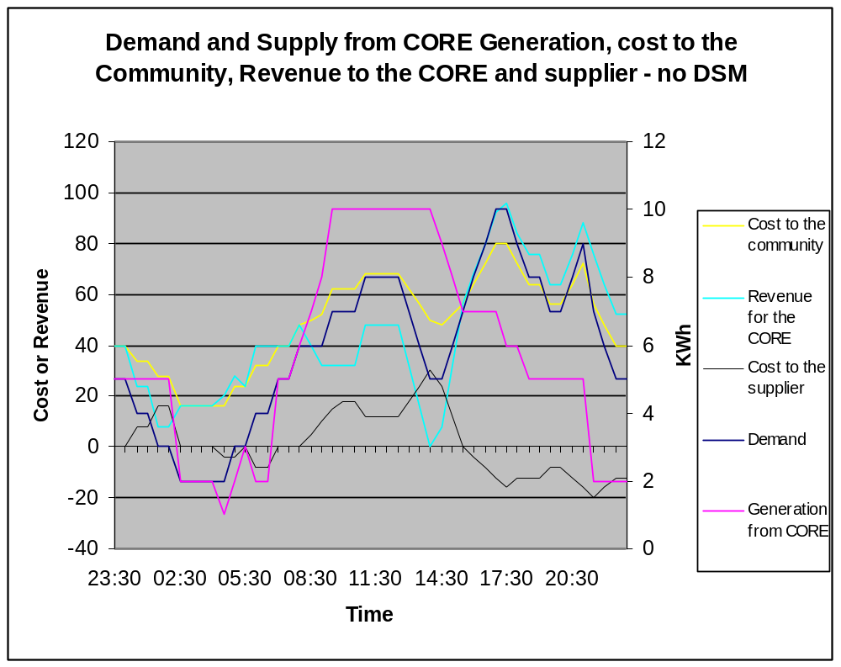
Figure 15 Example of supply and demand costs to the CORE and a supplier, fixed tariffs and no DSM.

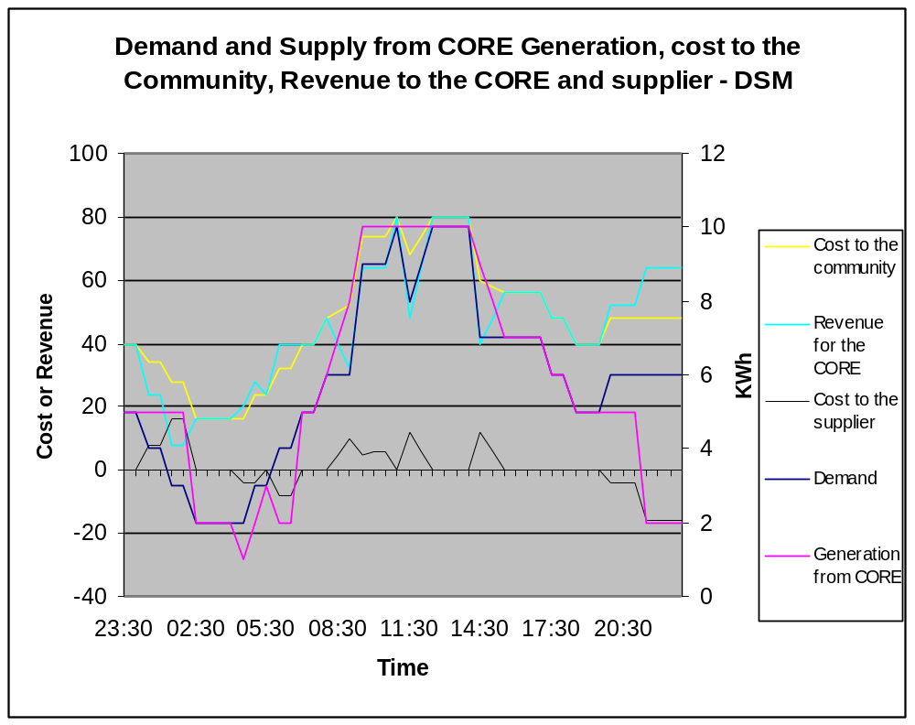
Figure 16 Example of supply and demand costs to the CORE and a supplier, fixed tariffs with DSM.
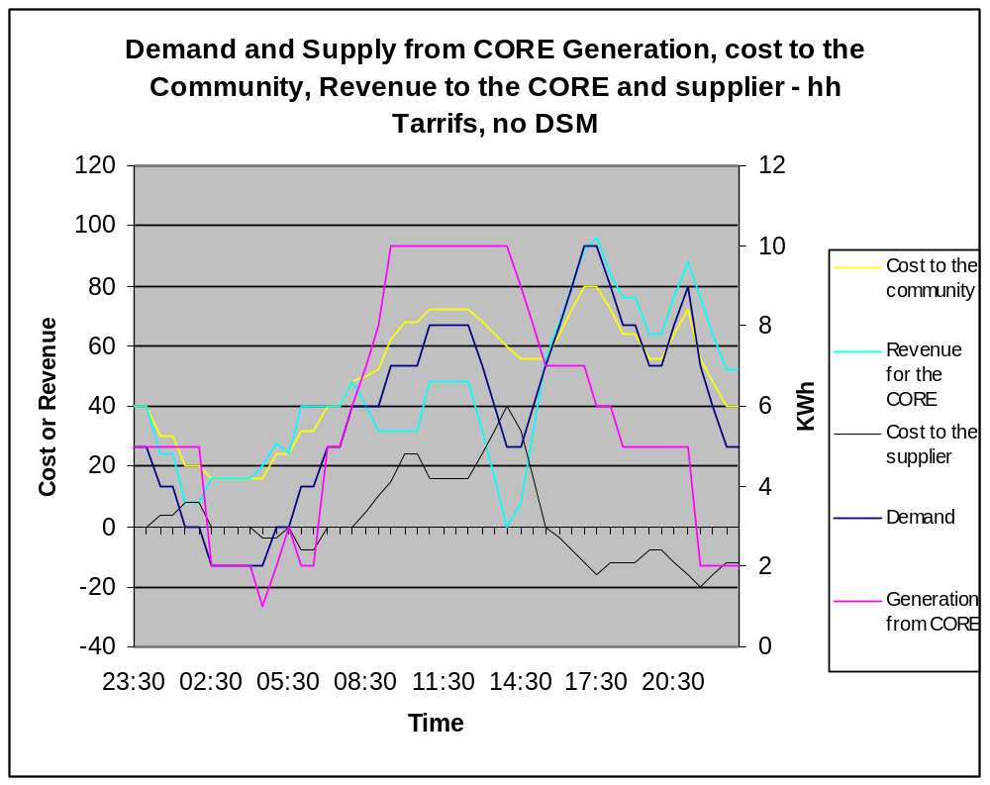
Figure 17 Example of supply and demand costs to the CORE and a supplier, half hourly tariffs and no DSM.

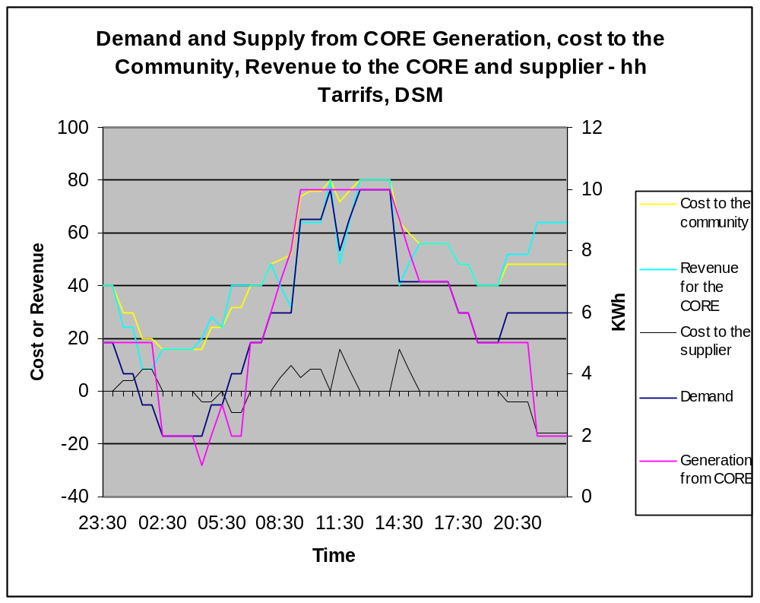
Figure 18 Example of supply and demand costs to the CORE and a supplier, half-hourly tariffs with DSM.

Challenges to the Model
The above model has been discussed with OFGEM who have not expressed any concerns in principle. There are, however, a couple of challenges to the model at present that need to be considered.

Firstly, as mentioned above, there is a lot of uncertainty about the policy and regulatory environment facing the energy sector at present. The outcome of decisions by the Government and OFGEM on topics such as the detailed implementation of exchanging all existing domestic meters for smart meters, funding options for small-scale low carbon generation technologies and the introduction of Feed-In Tariffs and a Renewable Heat Incentive could all have significant impacts for the operation of a CORE. Interested communities need to be aware of these developments and their implications as schemes such as a Feed-In Tariff may have limitations as to whether or not existing generators are eligible, for example.

There is also one significant barrier to the adoption of the model which is in relation to how transactions between parties in the electricity industry are currently agreed (the Settlement System). Presently, electricity consumption by small customers (i.e. domestic customers and business premises’ where the maximum demand is less than 100kW) are metered using a cumulative meter (i.e. it will just keep counting and metering readings are taken at the beginning and end of defined periods to calculate the bills). For customers that are on multiple tariffs (such as Economy 7 where a lower rate is charged for electricity used during certain hours overnight) a meter is used with more than one register to capture the electricity used on each tariff. As the meters capture the amount of electricity used at each tariff rate, suppliers can then bill their customers accordingly.

Wholesale electricity, however, is not valued at a flat rate but instead fluctuates across 48 half-hourly ‘Settlement Periods’. Suppliers are required to ensure they generate or purchase sufficient electricity in each of these periods to cover their customers’ consumption. The calculations of how much consumption each supplier is responsible for forms part of the Settlement System. As a supplier does not know how much electricity its small customers have used, a complicated system of ‘Class Profiles’ which deem (or estimate) when the electricity is likely to be consumed during every day of the year is used. These profiles are standardised and used across all suppliers to ensure that all small customers are accounted for in the same way. Given the number of small customers, the differences between properties even out across the whole of the country.

The problem for the model is that, by using DSM to optimise the use of locally produced power, the demand profile for the electricity that a CORE will need to import from a licensed supplier is unlikely to fit with this profile system. This is true of most DSM options for small customers that aim to dynamically shift consumption patterns from day to day. Suppliers approached as part of this work, whilst supportive of the concept, have expressed concern about how they could process transactions with a CORE to buy and sell the surplus and deficit of electricity as outlined in this project. As the profile system is standardised, under the present system there is no mechanism to reward or penalise customers for moving their load to times of the day when the price of power is cheaper or more expensive for the licensed supplier to buy. In addition, if many communities shifted their loads and used local generation, the error in the profiles would be noticeable.

There is an ongoing discussion within the electricity sector about moving away from these profiles but, until this happens, it is unclear whether or not a licensed supplier would be willing to work with a CORE as outlined in this model. These discussions are tied into the introduction of smart meters which is anticipated to be completed by 2020. In the interim, a Ashton Hayes could get round this problem by selling all of the electricity generated to a licensed supplier and then the stakeholders continuing to purchase their electricity from a licensed supplier as normal. Income from the generation could be used to pay off any financing arrangements for the generation, for example, and it may be possible to negotiate a special tariff for the community from the supplier purchasing the electricity generated. Further work will need to be done on an individual community basis to pursue negotiations with a supplier.

Recommendations For Ashton Hayes

- Carry out further detailed study to finalise the type, location and connection of generation.
- Work with Leapfrog to develop a CORE, contracts and a constitution. This should include contracts and insurance with the owners of host buildings.
- Develop business plan and fundraise for the project.
- The greatest hurdle to the model being adopted by a numerous communities across the country is the present balancing and settlement framework. EA Technology plan to approach suppliers to carry out a trial of smart metering and time of use tariffs on Church Road in Ashton Hayes. This would entail a supplier installing Smart meters and offering time of use tariffs to demonstrate the benefits and the best structures. If this is possible, the CORE should actively participate in the trial.
- At the same time as negoitiating such a trial, EA Technology will attempt to interest ScottishPower and possibly other DNOs, in a trial of innovative connection techniques for the proposed generation. If this is possible, the CORE should actively participate in the trial.

Appendix I
Glossary
anaerobic digestion biomass with a high moisture content is broken down by anaerobic microbes to give methane
anemometer measure device for wind speed and direction
Balancing and Settlement System the system for electricity trading in the UK
Biomass any organic material
Capacity Factor the energy generated in a year by a generator divided by the energy it would generate operating at its rated value for the whole year. Expressed as a percentage.
Combined Heat and Power (CHP) Generation of useable electricity and heat by the same generator.
Demand The amount of consumption of energy.
Demand Side Management (DSM) Moving demand to different times of the day reduce cost, match generation or reduce carbon emissions.
Distributed Generator An electricity generator connected to the distribution network.
Distribution Network The electricity network that delivers power to consumers
Distribution Network Operator The organisation that owns and operates a distribution network
Elexon The organisation that manages and operates the balancing and settlement system.
Energy Services Company An organisation managing, electricity, heat and generation for community(s) or company(s)
Gasification The combustion of biomass with a restricted air supply; this partial oxidation at elevated temperatures converts the solid biomass into a gas to drive an engine or a turbine.
Ground Source Heat Pump Extracts heat from the ground for heating systems
Hydro generation Electricity generated from the flow of water
kW Unit of electric power
kWh Unit of electric energy
Licensed supplier Company selling electricity and/or gas and licensed to operate in the balancing and settlement system
LV network The electricity system delivering power to domestic customers
MW Unit of electric power (1000 times a kW)
MWh Unit of electric energy (1000 times a kWh)
OFGEM The organisation the regulates the electricity and gas industry in the UK
Photovoltaic panels Generation of electricity from the sun using semiconducting material
profile Pattern of energy usage during the day or year
Pyrolysis The thermal degradation of biomass in the complete or nearly complete absence of air, to give a gas, an oil and charcoal.
pyranometer Device to measure the energy from the sun
Renewable Obligation Certificates Certificates used to reward renewable electricity
(ROC) generation in the UK
Settlement profile An average electricity profile over 1000s of consumers used in the Balancing and Settlement system.
Smartmeter Meters that are capable of actions such as recording energy consumption against time of day, using different tariffs, automatic metering reading and 2 way communications.
Solar Irradiance The amount of solar energy incident on a surface per unit time, per unit area
Transmission System The electricity system that transports bulk supplies across the country

Appendix II
Useful Contacts
Technology Specific
Electrical Storage http://www.electricitystorage.org
http://www.mpoweruk.com
Hydro Power http://www.british-hydro.co.uk
Wind Power http://www.bwea.com – this has links to a number of small wind turbines manufacturers websites.
http://www.bwea.com/noabl/. - wind speed data for the UK
http://data.ukedc.rl.ac.uk/browse/edc/Electricity/LoadProfile/data. Domestic electricity demand settlement profiles

General advice, Directories and Industry bodies
Renewable Energy http://www.r-e-a.net/
Association
Energy Saving Trust http://www.energysavingtrust.org.uk/
REAL assurance http://www.realassurance.org.uk/

Modelling
RETScreen http://www.retscreen.net/

Commercialising the Generation
Charity Commission
http://www.charitycommission.gov.uk
Community Interest Companies’ Regulator
http://www.cicregulator.gov.uk/index.shtml
Cooperatives UK http://www.cooperatives-uk.coop
Development Trust Association
http://www.dta.org.uk

Low Carbon Community Initiatives
Ashton Hayes Website http://goingcarbonneutral.co.uk/
Transition Towns www.transitiontowns.org
Low Carbon Communities http://lowcarboncommunity.org/
Greening communities http://new.lga.gov.uk/lga/core/page.do?pageId=18781

Appendix III

Below are examples of documents used for different aspects of the community engagement. The first document is a Question and Answer sheet to introduce the microgrid project. The second is the Memorandum of Understanding between the Parish Council and the project.

A number of focus groups and village meetings in Ashton Hayes were held to get feedback to the different proposals developed in the project. One focus group concerned the economic model and the other concerned the technology that might be used. Notes of these meetings were circulated and posted on the Ashton Hayes Going Carbon Neutral website (www.goingcarbonneutral.co.uk). Example copies are included below.



MEMORANDUM OF UNDERSTANDING made the day of 2008

BETWEEN:

- THE UNIVERSITY OF CHESTER, a higher education institution and a charity registered under number 525938, of Parkgate Road, Chester, Cheshire CH1 4BJ (“the University”)

(2) EA TECHNOLOGY LIMITED whose registered office is at Capenhurst Business Park, Capenhurst, Chester, CH1 6ES (“EA”) and

(3) ASHTON HAYES PARISH COUNCIL of c/o Andrea Thwaite, Parish Clerk, Ashton Hayes Parish Council, 64 Ringway, Waverton, Chester CH3 7NP. (“AHPC”)

(collectively “the Parties”).

- EA and the University have been successful in an application for grant funding for, and wish to collaborate on, a research project to study the feasibility of renewable energy microgrids in rural communities using Ashton Hayes as a test-bed (“the Project”). This Memorandum of Understanding sets out the way in which the Parties will co-operate with a view to ensuring that the outcomes of the Project are as successful as possible.

- All Project finance will be managed by the University and the Project work will be managed on a day-to-day basis by Roy Alexander on behalf of the University. He and Mary Gillie (representing EA) will meet from time to time to decide significant matters relating to the Project and will also put in place a structure to manage the Project. AHPC will on request appoint one or more representative(s) for consultation regarding the Project and to attend these meetings to inform and advise EA and the University. Seven days’ notice will be given of meetings unless prevented by exceptional circumstances.

3. EA and the University will arrange for Dr Mary Gillie and/or Professor Alexander respectively to attend meetings of AHPC or its Going Carbon Neutral Project sub-Committee for consultation regarding the Project and to inform and advise AHPC.

4. An outline of the Project Plan incorporating the main work tasks required to complete the Project is set out in the Schedule to this Agreement. AHPC will:

4.1 support the undertaking of the Project;

4.2 provide such assistance as EA and/or the University reasonably request to enable them to undertake the work tasks specified in the Project Plan and other reasonably incidental work tasks in accordance with the timescales shown;

4.3 play a positive, proactive and public role wherever possible in facilitating the Project and assisting with access to areas and buildings in Ashton Hayes, seeking and communicating to EA and the University the views and concerns of the community of Ashton Hayes and managing the interface between the Project, EA, the University and the local community; and

4.4 work together with the University and EA in implementing the Project and in bringing it to a successful outcome having regard to its objectives, which include the development of a model for a rural microgrid to control a cluster of small-scale renewable generation connected to the distribution network which allows a community to trade power and match demand and generation profiles, thereby reducing community CO₂ emissions.

5. All the Parties will share information openly regarding the progress of the Project and which may be of assistance in implementing the Project, undertaking the work tasks set out in the Schedule and in bringing the Project to a successful outcome having regard to the objectives of the Project specified above.

6. EA and the University will consult, involve and communicate with AHPC and the local community generally regarding the Project throughout the period of the Project.

7. For the avoidance of doubt, the Project is a feasibility study only. EA and the University undertake that, at the conclusion of the Project, relevant results will be shared with AHPC in the form of a discussion document giving recommendations for the village. There is no provision within the Project for implementation of a microgrid at Ashton Hayes and no further action will take place without full consultation with AHPC and residents of Ashton Hayes and the approval of AHPC.

8. The provisions of this Memorandum of Understanding are not legally binding, with the exception only of the provisions in paragraph 9 below.

9.1 APHC will not make any press release or any other public announcement or comment relating to the Project without the prior written approval of EA and the University. No press release or public announcement relating to the role of Ashton Hayes within the Project will be made by EA or the University without the prior written consent of AHPC.

9.2 The provisions in this paragraph 9 are legally binding, governed by English Law and subject to the jurisdiction of the English Courts.

Signed on behalf of EA TECHNOLOGY
LIMITED

.......................................................................

Signed on behalf of UNIVERSITY OF
CHESTER

.......................................................................

Signed on behalf of ASHTON HAYES
PARISH COUNCIL

.......................................................................


Appendix IV
Example of tasks needed to set up a CORE. Most of these are required to set up any legal organisation.

Task
Financing for generators
Agree Articles of Association (or equivalent)
Agree/Elect Officers
Set up organisation/s
Incorporate company through companies house (or equivalent)
Establish register of directors' interests
Set up banking arrangements
Take out insurances (professional indemnity?, liability, equipment of other people's property)
Appoint Auditors
Agree expenditure limits
Authorised signatories
Opening accounts
Negotiate with a services agency
Agree allocation method & initial tariff/s
5 year business plan
Set up framework contracts for generation, consumers, supplier, maintenance, leasing land, maintenance with a services agency
Data protection policy
Health & safety policy
Employment terms & contracts
PR
Contingency planning
Install generation
Start trading

Appendix V

These are the ongoing tasks and an illustration of many of them could be taken on by a Services Agency. Many of them are ownly need to be carried out once a year or infrequently and therefore there are significant cost savings in one organisation operating for many COREs.

Task | Frequency | Importance | Services agency
Fault alarm | Ad hoc | H | Y
Maintenance work - arrange | Ad hoc | H | Y
Metering disputes | Ad hoc | H | Y
Annual Return | Annual | H | Complexity reduced
Audit | Annual | H | Complexity reduced
Cashflow & P&L forecasts | Annual | H | Complexity reduced
Statutory accounts submission to Companies House | Annual | H | Complexity reduced
ROCs auctions | Bi-annual | H | Y
Tax & VAT payments | Bi-annual | H | Complexity reduced
Helpdesk | Daily | H | Y
Agreeing accounts with Energy supplier | Monthly | H | Y
Balance Sheet | Monthly | H | Complexity reduced
Billing | Monthly | H | Y
Management Accounts | Monthly | H | Y
Management Meetings & associated admin | Monthly | H | Y
Sampling of bills | Monthly | H | Y
Wages etc | Monthly | H | Y
Metering | ongoing | H | Y
Board Meetings & associated admin | Quarterly | H | Complexity reduced
Bank Reconciliation | Weekly | H | Y
Petty Cash | Weekly | H | N
Design / install new schemes | Ad hoc | M | Complexity reduced
Marketing / PR/ publicity | Ad hoc | M | Complexity reduced
New customers - set up billing arrangements | Ad hoc | M | Y
New customers - set up contracts | Ad hoc | M | Y
New customers - set up metering | Ad hoc | M | Y
New generation sites - set up legals | Ad hoc | M | Y
Contingency plan review | Annual | M | Complexity reduced
Maintain insurances | Annual | M | Y
Maintenance work - monitor agreements | Annual | M | Y
Rolling business plan | Annual | M | Complexity reduced
Tariff review | Annual | M | Complexity reduced
Ordering fuel for CHP | Bi-annual | M | Y
Energy efficiency advice | Daily | M | Complexity reduced
Compensation payments for hosting equipment | Monthly | M | Y
Maintenance work - settle invoices | Monthly | M | Y
Budgeting | Quarterly | M | Complexity reduced
Community relations - newsletter | Quarterly | M | N
Funding options to expand project | Ad hoc | L | Complexity reduced
Forecasting likely demand & output | Weekly | ?? | Y
Negotiating with suppliers | 2-3 years? | H | Y
Industry relations (e.g. DNO, Ofgem, other) | Ad hoc | H | Y
Reporting obligations for unlicensed supplier | ?? | ?? | Complexity reduced

http://www.nationalgrid.com/uk/Electricity/
More information on how the networks do this can be found at http://www.energynetworks.org/education/GCSE_factsheets/ElecFacts01_080513.pdf
http://www.elexon.co.uk/
Further information available at http://www.ofgem.gov.uk/Sustainability/Environment/Policy/SmallrGens/DistEng/Documents1/DE_Final_Proposals.pdf
http://www.reuters.com/article/environmentNews/idUSTRE4900A120081001?sp=true
OFGEM, ‘Biodiesel, glycerol and the Renewables Obligation’, March 2009, available at http://www.ofgem.gov.uk/Sustainability/Environment/RenewablObl/Documents1/Biodiesel%20Decision.pdf
Further information can be found at http://www.planningportal.gov.uk/england/genpub/en/1115315762558.html
http://www.communities.gov.uk/documents/planningandbuilding/pdf/147444.pdf
Further information on this code is available from Elexon, who are currently responsible for administering it, at http://www.elexon.co.uk.
http://www.cicregulator.gov.uk/index.shtml
http://www.cooperatives-uk.coop/Home/miniwebs/miniwebsA-z/whatIsACo-operative/co-operativeIdentity
http://www.cooperatives-uk.coop
http://www.dta.org.uk/aboutourmembers/whatisadevelopmenttrust.htm
http://www.dta.org.uk/
http://www.charitycommission.gov.uk
Energy Act 2008, s.41-43
Available at http://hes.decc.gov.uk/.
This document provides further information on ROCs (http://www.ofgem.gov.uk/Sustainability/Environment/RenewablObl/Documents1/publication%20draft%20microgeneration09.pdf) and is specifically targeted at smaller schemes (<50kW). The RO is updated on an annual basis and it is therefore important that communities check OFGEM’s website to ensure they have the most up-to-date information on the scheme.
See http://www.nfpa.co.uk
Further information is available from Elexon (http://www.elexon.co.uk).

